# MUNICIPAL SOLID WASTE AGREEMENT

This Municipal Solid Waste Agreement (this “Agreement”) is entered into as of the day of , 2021, between the **Universal City, Texas** (“City”), acting by and through its duly authorized signatory, and **Waste Management of Texas, Inc.** (“Contractor”), a Texas corporation, acting by and through its duly authorized representative.

# W I T N E S S E T H:

**WHEREAS,** the City desires to grant to Contractor the exclusive right to continue operating and maintaining the service of collection, transportation, and disposal of residential, commercial and industrial waste, over, upon, along and across the present and future streets, alleys, bridges, and public properties of the City, subject to the terms of this Agreement; and

**WHEREAS**, Contractor desires to continue operating and maintaining the service of collection and transportation of residential garbage and trash, over, upon, along and across the present and future streets, alleys, bridges, and public properties of the City, subject to the terms of this Agreement.

**NOW, THEREFORE**, for and in consideration of the sum of Ten Dollars ($10.00) and other good and valuable consideration, the receipt and sufficiency of which are hereby acknowledged and confessed, the parties hereto agree as follows:

# DEFINITIONS:

* 1. At Your Door (AYD) Service:
  2. Bagster: add here or under Bulky Waste and denote that it is a fee based service billed directly by WM.

* 1. **Brush**: Tree, shrub, grass, brush trimmings, leaves, limbs, shrubbery and other yard waste and green material securely tied together to form an easily handled bundle or placed in brown paper yard debris bags that is generated by or at Residential Unit Customer locations and placed curbside for collection. Limbs shall not exceed four feet (4’) in length or six inches (6”) in diameter.
  2. **Bulk Waste**: Furniture, bicycles (without tires), refrigerators that have CFCs removed by a certified technician, stoves, and other oversized wastes which are customary to ordinary housekeeping operations of a Residential Unit and whose large size precludes or complicates its handling by normal solid waste collection, processing or disposal methods. Curbside Collection of Bulk Waste is excluded from this Agreement. See Bagster in section 1.02
  3. **City**: The City of Universal City, Texas.
  4. **Commercial Unit**: All commercial businesses and establishments, including, but not limited to, stores, offices, restaurants, warehouses, temporary mobile-home/trailer or RV parks, apartments and related facilities, premises, locations or entities, public or private, within the

corporate limits of the City.

* 1. **Commercial Waste**: All Garbage, Waste, and Rubbish generated by a Commercial Unit, excluding Unacceptable Waste.
  2. **Construction Debris**: Waste building materials resulting from construction, remodeling, repair, or demolition operations that are directly or indirectly the by-products of construction work or that result from demolition of buildings or other structures, but specifically excluding land-clearing debris, yard debris, or used asphalt, asphalt mixed with dirt, sand, gravel, rock, concrete, or similar materials.
  3. **Contract Administrator**: That person, or his designee, designated by the City to administer and monitor the provisions of this Agreement.
  4. **Contractor**: Waste Management of Texas, Inc.
  5. **Customer**: The owner or tenant of a Residential Unit, Industrial Unit, or Commercial Unit located within the City, and identified by the City as being eligible for and in need of the services provided by the Contractor under this Agreement.
  6. **Dead Animals**: Animals or portions thereof that have expired from any cause except those slaughtered or killed for human use.
  7. **Disposal Site**: A duly permitted sanitary landfill selected by Contractor.
  8. **Dumpster**: Metal receptacle designed to be lifted and emptied mechanically for use only at Commercial Units or Industrial Units.
  9. **Garbage**: Solid Waste consisting of putrescible or animal and vegetable waste materials resulting from the handling, preparation, cooking, and consumption of food, including waste materials from markets, storage facilities, handling and sale of produce and other food products, and all Dead Animals of less than ten pounds (10 lbs.) in weight, except those slaughtered for human consumption.
  10. **Hazardous Waste**: Any material or waste identified or listed as a hazardous waste by the administrator of the Environmental Protection Agency under the Federal Solid Waste Disposal Act as amended by RCRA, 42 U.S.C. §6901, *et. seq*., as amended.
  11. **Industrial Unit**: All industrial businesses and establishments, including manufacturing facilities, temporary construction sites, and other premises, locations or entities, public or private, within the corporate limits of the City.
  12. **Industrial Waste**: Solid Waste resulting from or incidental to any

process of industry, manufacturing, construction, demolition, mining or agricultural operations. Industrial Waste includes Construction Debris, but excludes Unacceptable Waste.

* 1. **Light Commercial Unit**: A retail or light commercial type of business, which generates no more than one (1) cubic yard of Garbage, Rubbish, and Refuse per week, excluding Unacceptable Waste. A multi-family dwelling (duplex, triplex, quadruplex, condominium/row home – excluding apartments) consisting of more than one family shall be treated as a Light Commercial Unit. Each single-family dwelling within any such multi- family dwelling (duplex, triplex, quadruplex, condominium/row home – excluding apartments) shall be billed separately as a Light Commercial Unit.
  2. **Medical Waste**. Waste generated by health care related facilities and associated with health care activities, not including Garbage or Rubbish generated from offices, kitchens, or other non-health-care activities. The term includes Special Waste from health care-related facilities which is comprised of animal waste, bulk blood and blood products, microbiological waste, pathological waste, and sharps as those terms are defined in 25 TAC §1.132 (relating to Definitions).
  3. **Non-Recyclables:** Any materials in the Single Stream Materials that are not Recyclables.
  4. **Polycart**: A Contractor owned rubber-wheeled receptacle with a maximum capacity of 90 - 96 gallons constructed of plastic, metal and/or fiberglass, designed for automated or semi-automated solid waste or recyclables collection systems, and having a tight-fitting lid capable of preventing entrance into the container by small animals. The weight of a Polycart and its contents shall not exceed 175 lbs.
  5. **Recyclable Materials or Recyclables**: A material that has been recovered or diverted from the non-hazardous waste stream for purposes of reuse, recycling, or reclamation, a substantial portion of which is consistently used in the manufacture of products that may otherwise by produced using raw or virgin materials. Recyclable Material is not solid waste. However, Recyclable Material may become Solid Waste at such time, if any, as it is abandoned or disposed of rather than recycled, whereupon it will be solid waste, with respect to the party actually abandoning or disposing of such material.
  6. **Recycling Cart:** A Polycart provided to a Residential Unit for the deposit of Recyclable Materials.
  7. **Residential Unit:** A residential dwelling within the service area of the City occupied by a person or group of persons comprising not more than one family. A Residential Unit shall be deemed occupied when either

water or domestic light and power services are being supplied thereto.

1.24 **Residential Waste**: All Garbage, Rubbish and Waste generated by a Customer at a Residential Unit, excluding Unacceptable Waste and Construction Debris generated by a Third-Party Provider.

* 1. **Rubbish**: Nonputrescible Solid Waste (excluding ashes), consisting of both combustible and noncombustible waste materials. Combustible rubbish includes paper, rags, cartons, wood, wood shavings, furniture, rubber, plastics, yard trimmings, leaves, brush or similar materials; noncombustible rubbish includes glass, crockery, tin cans, aluminum cans, metal furniture, and similar materials that will not burn at ordinary incinerator temperatures (1,600 degrees Fahrenheit to 1,800 degrees Fahrenheit).
  2. **Single Stream Materials**: means all materials deposited by a Customer in the Customer’s Recycling Cart, including any Recyclables and Non- Recyclables.
  3. **Solid Waste or Waste**: Non-hazardous solid waste generated by a Customer at a Residential Unit to be collected by Contractor under this Agreement. Solid Waste excludes Unacceptable Waste.

1.27 **Special Waste**: Waste that requires special handling and management due to the nature of the waste, including, but not limited to, the following: (A) containerized waste (e.g. a drum, barrel, portable tank, box, pail, etc.), (B) waste transported in bulk tanker, (C) liquid waste, (D) sludge waste, (E) waste from an industrial process, (F) waste from a pollution control process, (G) residue and debris from the cleanup of a spill or release of chemical(s), or (H) any other waste defined by applicable law, rule or regulation as "Special Waste".

* 1. **Third-Party Provider**: A commercial business enterprise or third party that provides any type of services to Residential Units or construction sites.
  2. **Unacceptable Waste**: Any waste or material that (i) the acceptance and handling of which by Contractor would cause a violation of any permit, condition, legal or regulatory requirement, (ii) substantial damage to Contractor's equipment or facilities, or (iii) contains information (in hard copy or electronic format) that is protected or regulated under any local, state or federal privacy or data security laws, including without limitation, the Health Insurance Portability and Accountability Act (HIPAA), or (iv) presents a danger to the health or safety of the public or Contractor's employees, and/or (v) is or contains Hazardous Waste, Special Waste, untreated Medical Waste, Dead Animals weighing ten pounds (10 lbs.) or greater, or (vi) is or contains solid or dissolved material in domestic sewage, or solid or dissolved material in irrigation return flows, or

industrial discharges subject to regulation by permit, or (vii) is soil, dirt, rock, sand, and other natural or man-made inert solid materials used to fill land if the object of the fill is to make the land suitable for the construction of surface improvements, or (viii) results from activities associated with the exploration, development, or production of oil or gas or geothermal resources.

* 1. **Unusual Accumulations or Overage**: As to Residential Units, any Waste placed curbside for collection or placed outside, on top of or sticking out of a Polycart. As to Commercial Units and Industrial Units, (i) any Waste or other material placed on top of or located outside the Dumpster, Roll- off Bin or Compactor regularly used for such collection service or (ii) in excess of the applicable weight limits or intended capacity such that the lid will not completely close.

1.31. **Waste Polycart:** A Polycart provided to a Residential Unit or Light Commercial Unit for the deposit of Waste.

# GRANT OF EXCLUSIVE FRANCHISE:

Contractor is hereby granted the exclusive right and privilege within the corporate limits of the City to conduct business for the purpose of collection and disposal of Waste from Residential Units, collection of Commercial and Industrial Waste from Commercial and Industrial Units and Construction Debris generated at Residential, Commercial, or Industrial Units, including commercial or industrial temporary construction sites subject to the terms hereof, including any tracts, territories and areas hereafter annexed to or acquired by City.

# TERM:

The term of this Agreement shall commence _ , 2021 (“Commencement Date”) and continue to remain in full force and effect for a period of 5 years through , 2026. The term of this Agreement shall automatically extend without further action of the parties for an additional term of five (5) years, unless not less than ninety (90) days before the termination of the term, one party advises the other in writing of its desire to terminate this Agreement at the conclusion of the term of the Agreement.

# RATES:

Contractor is authorized to charge, and shall receive from the City, the rates set forth on **Schedule “A”** ("Base Rates") attached hereto and incorporated herein by reference upon the Commencement Date of this Agreement. The Base Rates are subject to adjustment as set forth in Section 9 below.

# CONTRACTOR SERVICES:

* 1. **Residential Collection**: For those Residential Unit Customers that Contractor has not already provided a Waste Polycart and a Recycling Polycart, if any, Contractor agrees to provide such Polycarts to those Customers by . A

Residential Unit Customer has the right to request an additional Polycart and Contractor agrees to provide an additional Cart at the rate set forth in Schedule A.

* + 1. Contractor shall collect Residential Waste generated at a Residential Unit and placed in that Residential Unit’s Waste Polycart two times per week but not less than three days between collection times. The Contractor shall not be obligated to collect any Waste not properly contained in the Customer’s Waste Polycart.
    2. Construction Debris generated at a Residential Unit by the owner or tenant of that Residential Unit, and not using the services of a Third-Party Provider, shall be subject to the Bulky Waste limitations set forth in this Agreement. Any Waste or Bulky Waste generated by a Third-Party Provider is Commercial Waste and Contractor has no obligation to collect those materials.
    3. Contractor shall collect Waste placed in a Waste Cart from a Light Commercial Unit once per week.
  1. **Brush Collection**: Contractor shall provide a twice per year collection service in the months of October and April to Residential Units for collection of Brush. Contractor agrees to collect up to, but not to exceed, a total of six (6) cubic yards of Brush from each Residential Unit. Contractor shall have no obligation to collect any Brush in excess of the above volume, Brush shall be placed within three (3) feet of the curb, swale, paved surface of the roadway, closest accessible roadway, or other location agreed to by Contractor and Customer, that will provide safe and efficient accessibility to Contractor's collection crew and vehicle.

Collection of Residential Unit Bulky Waste is not included in this Agreement. Construction Debris generated by a Third-Party Provider hired by a Residential Unit Customer and generated and/or located at that Residential Unit is considered and shall be treated as Commercial Waste.

* 1. **Residential Door-to-Truck Service:** Contractor will provide, at no cost to the City or the Residential Customer, Residential Door-To-Truck waste collection for up to 20 Residential Customers that the City determines have demonstrated a need or hardship necessitating this special service. The City has sole responsibility for determining which Residential Unit Customers qualify for this special service. The City will provide Contractor with a complete list of qualifying Customers’ addresses each time a modification is made. Door-to-Truck collection service means the Customer places their Waste Polycart near their garage or carport rather than curbside. Contractor may refuse to provide this service if the location of the Polycart exceeds 150 feet from the curb line or edge of pavement and no such service will be provided for Bulky Waste or Brush collection.
  2. **Residential Recyclables Collection:**

1. Contractor shall collect Residential Unit Recyclables once per week, per an agreed upon schedule with the City. Residential Unit Customers must place all Recyclables into the Recycling Cart. Contractor shall not be required to collect any Recyclable Materials that are not placed in a Recycling Cart. In

addition, Contractor shall not be required to collect Recyclable Materials if the Customer does not segregate the Recyclable Materials from the remainder of the Residential Waste.

1. **Recyclables Specifications**: The following are Recyclables that Customers may deposit into the Recyclables Carts. To be acceptable, the Recyclables must be dry, loose (not bagged), unshredded, empty and include only the following:

|  |  |
| --- | --- |
| Aluminum cans | Newspaper |
| PET bottles with the symbol #1 – with screw tops only | Mail |
| HDPE plastic bottles with the symbol #2 (milk, water bottles detergent, and  shampoo bottles, etc.) | Uncoated paperboard (ex. cereal boxes; food and snack boxes) |
| PP plastic bottles and tubs with symbol # 5 - empty | Uncoated printing, writing and office paper |
| Steel and tin cans | Old corrugated containers/cardboard (uncoated) |
| Glass food and beverage containers – brown, clear, or green | Magazines, glossy inserts and pamphlets |

**Non-Recyclables include, but are not limited to, the following:**

|  |  |
| --- | --- |
| Plastic bags and bagged materials (even if containing Recyclables) | Microwavable trays |
| Porcelain and ceramics | Light bulbs, Mirrors |
| Window or auto glass | Coated cardboard |
| Soiled paper, including paper plates, cups and pizza boxes | Plastics not listed above including but not limited to those with symbols #3, #4, #6, #7 and unnumbered plastics, including utensils |
| Expanded polystyrene | Coat hangers |
| Glass and metal cookware/bakeware | Household appliances and electronics |
| Hoses, cords, wires | Yard waste, construction debris, and wood |
| Flexible plastic or film packaging and multi-laminated materials | Needles, syringes, IV bags or other medical supplies |
| Food waste and liquids, containers containing such items | Textiles, cloth, or any fabric (bedding, pillows, sheets, etc.) |
| Excluded Materials or containers which contained Excluded Materials | Napkins, paper towels, tissue, paper plates, paper cups, and plastic utensils |
| Any paper Recyclable materials or  pieces of paper Recyclables less than 4” in size in any dimension | Propane tanks, batteries |
| Cartons | Aseptic Containers |

1. **Delivery Specifications.** Residential Unit Customers shall deposit only the Recyclables listed above into their Recyclables Carts. If a load of material does not meet these specifications, the Recycling Facility may reject the load and the City may be charged for the resulting transportation, handling, and disposal costs for the Non- Recyclables. The Recycling Facility or Contractor has the right to dispose of all residue, contamination, and Non-Recyclables resulting from or remaining after the processing of

the materials collected from the Recyclables Carts under this Agreement. The City acknowledges that Contractor may face unforeseen charges or increases based on the recycling market, the quality of the materials collected within the City, and/or uncontrollable circumstances, including without limitation, changes in law, and the City agrees to pay these substantiated charges.

1. **Recycling Market Changes:** The market for Recyclables continues to evolve and is volatile. As such, Contractor cannot make any representations as to the marketability of the Recyclables, and when no reasonable commercial market exists for a commodity, Contractor and/or the Recycling Facility reserves the right to dispose of that material. Contractor also reserves the right to add or delete materials from the list of Recyclables based upon requests or demands from the Recycling Facility, changes in market conditions, uncontrollable circumstances, governmental restraint, or changes in laws, rules, regulations, or ordinances, and Contractor will provide written notice to the City of those changes. The Recycling Facility reserves the right to dispose of particular Recyclables when no reasonable commercial market exists for a commodity. In the event that a change in applicable law or a material change in market conditions that has the effect of materially altering the terms of this Agreement or substantially affects the benefit(s) bargained for by the parties, the parties agree to amend the terms of the recycling portion of the Agreement to reflect the current market or legal conditions.
   1. **Carts/Polycarts/Placement**:
      1. Contractor agrees to provide one (1) Waste Polycart and (1) Recycling Cart to each Residential Unit for the deposit of Waste and Recyclables. The Carts shall be placed by the Customer of a Residential Unit in a location that is readily accessible to Contractor and its collection equipment, not to exceed three (3) feet from the curb or edge of the travelled portion of the street, road or alley, and not to be located in a manner that will block the driveway or mailbox or otherwise inhibit proper servicing. The City shall aid Contractor in resolving problems of Cart location by the Customer. Customers shall not overload Carts, and the Carts shall be loaded such that the lids shall close securely.
      2. Contractor shall not be required to collect (i) any Residential Waste or Recyclables that are not placed in a Polycart, (ii) any Residential Waste or Recyclables from a Polycart that is overloaded or whose lid cannot fully close, or (iii) a Polycart that is not properly placed curbside. Contractor shall have no obligation to collect Unusual Accumulations/Overage and may charge for the collection of same so long as Contractor provides a digital image or photograph of the Overage to the Residential Unit Customer upon request.
      3. The Carts furnished by the Contractor hereunder shall remain the property of Contractor, and the Customer will have no interest in the Carts. The Carts shall remain at the location of the Residential Unit where delivered by

Contractor. If a Cart is damaged beyond repair, the Contractor will provide a replacement Cart to the Residential Unit location at no charge. Any Cart removed from, lost or missing from a Customer location shall be deemed lost, and Contractor agrees to provide a replacement Cart at a cost of $70.00 per Cart to the City.

* 1. **Residential Household Special Waste Collection Program**: Contractor agrees to provide a residential household hazardous waste collection service pursuant to the terms set forth in **Schedule C**, the At-Your-Door Program.
  2. **Commercial and Industrial Unit Collection**: Contractor shall have the exclusive right to collect and transport Commercial Waste from the Commercial Units and Industrial Waste from the Industrial Units, respectively, utilizing Dumpsters, Compactors or Roll Off Bins, at such frequency as shall be reasonably requested and agreed to between the Customer and Contractor. The Dumpster, Compactor or Roll Off Bin shall be located on a concrete pad to accommodate equipment and at a location reasonably acceptable to Contractor. Contractor may, at its sole option, require Commercial or Industrial Unit Customers to enter into individual contracts with Contractor, subject to the terms of this Agreement.
  3. **Unusual Accumulations Collection/Overage**: Contractor shall have no obligation to collect Unusual Accumulations/Overage and may charge for the collection of same so long as Contractor provides a digital image or photograph of the Overage to the Commercial or Industrial Unit Customer upon request.
  4. **Unacceptable Waste**: Contractor shall not be obligated to collect any Unacceptable Waste. Title to Unacceptable Waste shall not pass to Contractor, and liability for any Unacceptable Waste shall remain with the generator of such material.

5.09 **Services Provided to City or City Facilities:**

1. The Contractor will provide, at no charge, Waste collection services two times per week, but not less than three days between collection times, at the City facilities listed in **Schedule B**. The Waste containers provided at each City facility will be of the size and type appropriate to the volume and characteristics of the Waste and as set forth in Schedule B. Additional or new City facilities or buildings will only be serviced by Contractor at no charge upon the mutual written agreement of both parties.
2. Contractor will provide to the City, at no additional charge, two (2) ~~one (1)~~ forty cubic yard Roll-Off container at a location determined by the City Public Works Department and agreed to by Contractor. Contractor will provide a maximum of 180 ~~125~~ prescheduled pulls each calendar year at no charge to the City. These 180 ~~125~~ Roll-Off pulls must be used during each calendar year and may not be accumulated and rolled into the following calendar year. The weight of the Roll-Off shall not exceed eight (8) tons per pull. The City is required to electronically notify the Contractor of the

requested pull(s) for the 40 cubic yard Roll-Off via the Contractor’s PSS Customer Service Team. Contractor shall charge and the City agrees to pay the rate set forth in Schedule A for any Roll-Off load heavier than the eight-ton limit, provided Contractor notifies the City within three (3) business days of an overweight load. Otherwise, there will be no additional charge for over-limit loads. Additional pulls will be charged to the City per the then-current rates in **Schedule A.**

1. Contractor will provide special collection services daily at designated locations during the City's annual fall and spring cleanup. Six (6) forty-cubic-yard roll-off containers will be provided each work day to the City for each such annual fall and spring cleanup where only residential Bulky Waste will be collected. Container and pickup service will be at no cost to the City. Such fall and spring clean-ups shall not exceed two (2) weeks each and number of roll-off container pulls shall not exceed 60 ~~30~~ for each clean- up. The City will be charged the current applicable rate in **Schedule A** for any load heavier than the eight-ton limit, provided Contractor notifies the City within three (3) business days of an overweight load. Otherwise, there will be no additional charge for over-limit loads. Additional pulls will be charged to the City at the then-current rate in Schedule A. Contractor shall have no obligation to haul any roll-off that contains construction, commercial, or industrial waste. The City will be requested to remove such waste from the roll-off. If the City is unable to remove the waste, WM has the right to transport and dispose of the roll-off contents at the applicable rate for such waste type.

# COLLECTION OPERATION:

* 1. **Hours of Operation**: Collection of SFR Residential Waste and Light Commercial Waste shall begin no earlier than 7:00 A.M. and shall generally not extend beyond 6:00 P.M. Collection of Commercial Waste or Industrial Waste shall begin no earlier than 6:00 a.m. and shall generally not extend beyond 6:00 p.m. No collections shall be made on Sunday.
  2. **Routes of Collection**: Collection routes shall be established by the Contractor as reasonably approved by City. City shall provide Contractor with maps of the City containing sufficient detail for Contractor to design collection routes. Contractor shall provide to the City route maps for approval by the City, which approval shall not be unreasonably withheld.
  3. **Holidays**: The following shall be holidays for purposes of this Agreement:

|  |  |  |
| --- | --- | --- |
| New Year's Day | Labor Day | Thanksgiving Day |
| Independence Day | Memorial Day | Christmas Day |

Contractor may decide to observe any or all of the above-mentioned holidays by suspension or collection service on the holiday, but the Contractor shall be responsible for providing make-up collection for residential routes that occur on specified holidays. Make-up days shall be the next business day following the

holiday and every remaining route day scheduled for that week will be pushed a day.

* 1. **Complaints**: Customer complaints shall be directed by the City to Contractor, and Contractor shall promptly resolve such complaint based on the nature of the complaint. Contractor shall be responsible for maintaining a log of complaints based on the information provided to Contractor by the City, and shall provide the City, on a monthly basis, with copies of all complaints indicating the date and hour of the complaint, nature of the complaint, and the manner and timing of its resolution. Any alleged missed pickups will be investigated and, if such allegations are verified, Contractor shall arrange for collection on the next business day after receipt of such complaint. If the missed pickup is a result of Customer related acts or omissions, the City shall take appropriate action to cause such Customer to subsequently properly set out such Waste.
  2. **Collection Equipment**: Contractor, at its sole cost and expense, agrees to furnish, all trucks, equipment, machines, and labor which are reasonably necessary to adequately, efficiently, and properly collect and transport Waste from Customers serviced by Contractor in accordance with this Agreement.
  3. **Disposal**: The Contractor shall deliver Waste collected to a duly permitted Disposal Site operated in compliance with rules stipulated by the applicable state agency and/or the U.S. Environmental Protection Agency.
  4. **Spillage**: The Contractor shall not be responsible for scattered Refuse unless the same has been caused by Contractor, in which case all scattered Refuse shall be picked up immediately by Contractor.
  5. **Vicious Animals**: Employees of the Contractor shall not be required to expose themselves to the dangers of vicious animals in order to accomplish Refuse collection service. Contractor shall immediately notify the City, in writing, of such condition and of his inability to make collection.
  6. **Protection From Scattering**: Each Contractor vehicle shall be equipped with a cover which may be net with mesh not greater than one and one-half (1-1/2) inches, or tarpaulin, or fully enclosed metal top to prevent leakage, blowing or scattering of refuse onto public or private property.

6.10. **Point of Contact**. All dealings and contacts between Contractor and the City shall be directed between Public Sector Solutions Manager of Contractor, or such other individual identified by Contractor, and the Contract Administrator designated by the City.

# LICENSE AND TAXES:

Contractor shall obtain at its sole expense all licenses and permits required by the City and the State and shall maintain same in full force and effect.

# BILLING:

1. City shall provide billing and bill collection services for Residential Units. Within twenty-one (21) days of the end of each month during which collection services are provided by Contractor hereunder, Contractor shall submit to the City an invoice setting forth sums due by the City to Contractor for services rendered under this Agreement for the prior month. City shall remit to Contractor payment for such services within thirty (30) days after receipt of invoice. Past due invoices shall bear interest at the highest rate permitted by law. The City shall notify, in writing, and request that Contractor suspend services to any Residential Unit Customer that has failed to pay the City for Waste or Recyclables collection services, and Contractor shall have the right to suspend service to such delinquent Customer until notified by the City to resume such services. The City’s franchise, billing, or administrative fees, if any, will not be included in the Contractor’s invoices to the City for services provided to Residential Units. The City shall include in its bills sent directly to Residential Units any City franchise, billing, or administrative fees and shall retain those fees.
2. Contractor shall provide billing and bill collection services for all Commercial and Industrial Unit Customers including Light Commercial Customers, that use Polycarts, Dumpsters, Compactors, or Roll-Off Bins. Within 21 days of the end of each month during which collection services are provided by Contractor hereunder, Contractor shall submit an invoice to each Commercial and Industrial Customer.
   1. Contractor shall include in its invoices to the Customer the City’s franchise fee of ten percent (10%) (“Franchise Fee”) for Commercial and Light Commercial Customers that use Polycarts or Dumpsters, along the City’s franchise fee of 15 percent (15%) for Industrial Compactors or Roll-Offs. The Franchise Fee payments actually received by Contractor from Customers shall be paid by the Contractor to the City within thirty (30) days after the last day of the month of Contractor’s actual receipt of such monies. The rates set forth in **Schedule A** include the City’s Franchise Fee. The Franchise Fee shall not be added to and/or be assessed upon any state or local sales tax or other governmental fees, such as the state of Texas disposal fee, or the Franchise Fee itself.
   2. Invoices sent to Commercial, Light Commercial and Industrial Unit Customers by Contractor shall be paid within thirty (30) days after receipt of such invoice by Customer or in accordance with each individual contract between Customer and Contractor, if any. All past due invoices shall bear interest at the highest rate permitted by law. Contractor shall have the right to suspend service to any Customer that is delinquent in payment directly to Contractor. If Contractor suspends service to a Customer for failure to timely pay Contractor’s invoices, Contractor has the right to charge a service reactivation fee and/or finance charges or late payment fees if such service to the Customer is reinstated.

# MODIFICATION TO RATES:

* 1. **CPI Adjustment**. Base Rates charged by Contractor for services will remain fixed as set forth on Schedule "A" and will not be increased for changes in the CPI (as hereinafter defined), until the first anniversary of the Agreement Commencement Date (“**Anniversary Date**”). Continuing annually on each Anniversary Date thereafter, the Base Rates for services shall be adjusted by eighty-five percent (85%) of the average monthly percentage increase that the Consumer Price Index, US City Average for All Urban Consumers, Garbage and Trash, Not Seasonally Adjusted, Base Period December 1983 = 100 (published by the United States Bureau of Labor Statistics, Consumer Price Index) (the “C.P.I.”) has increased over the 12 most recently published months. The

C.P.I. published on the first Monday prior to the end of April (or the first business day thereafter if such Monday is a Federal Holiday) shall be used to determine the monthly percentage increase change. The average will be determined by calculating the percentage increase change in the CPI each month during the applicable 12-month period. Once that average is determined, then the average increase change for the 12- month period for the prior year will be subtracted and that sum will be multiplied by 85%. The product shall be the CPI adjustment component of the annual modification to Base Rates. In the event the U.S. Department of Labor, Bureau of Labor Statistics ceases to publish the C.P.I., the parties hereto agree to substitute another equally authoritative measure of change in the purchasing power of the U.S. dollar as may be then available so as to carry out the intent of this provision. The percentage increase change shall be multiplied by 85% and the product thereof shall be the “CPI Adjustment Component” of the annual modification to Base Rates.

* 1. **Fuel Adjustment**. Beginning on the Anniversary Date and every anniversary thereafter, the Base Rates shall be adjusted by 15% of the average percentage increase or decrease in the price of compressed natural gas determined by the Energy Information Administration of the US Department of Energy (“EIA/DOE”)’s Natural Gas Commercial Price-Texas Index during the applicable 12-month time period. The average will be computed by calculating the percentage change in the EIA/DOE price each month during the applicable 12-month period. Once that average is determined, then the average change for the 12 month period during the prior year will be subtracted and that sum will be multiplied by 15%. product thereof shall be the fuel adjustment component” of the annual modification to Base Rates.
  2. **Additional Adjustments**. Contractor may also be entitled to an increase in Base Rates from time to time during the term of this Agreement to offset any substantiated change in conditions which increase the Contractor’s costs, including but not limited to, increases in disposal costs, increases in landfill fees, changes in the ordinances under which the Contractor is to operate, or changes in federal, state or local laws, rules or regulations. Documentation of such increases shall be submitted to the City upon the City’s request.

# CITY'S OBLIGATIONS:

The City agrees to perform all obligations required of the City pursuant to the terms of this Agreement, including, but not limited to, the following:

1. The City shall designate the Contract Administrator, who shall communicate City decisions to Contractor on a timely basis from time to time as required under this Agreement;
2. The City shall provide the total number of Residential Units to the Contractor no later than the 25th day of each month (i.e., the total house count that will receive Contractor services). Contractor will use that monthly Residential Unit total in its next invoice to the City or Contractor will use the most recent monthly total provided by the City. Contractor has the right to rely upon the total house count numbers provided by the City. Any errors or mistakes in the total house count provided by the City to Contractor shall be corrected within 6 months of the date provided to the Contractor or the mistake is waived and released by both parties. Contractor has the right, but not the obligation, to verify the total house count provided by the City. If the City fails to provide a monthly house count, Contractor will use the most recent house count provided by the City;
3. The City shall timely pay Contractor pursuant to Section 8 of this Agreement;
4. The City shall timely inform Contractor of complaints made by Customers;
5. The City shall work with Contractor in good faith to resolve complex Customer service issues; and
6. The City shall educate Customers to encourage, promote and obtain proper Waste disposal as required by this Agreement, including educating Residential Unit Customers to assure proper and timely Cart set out.
7. City shall provide Contractor with maps (GIS Shapefiles) of the City containing sufficient detail for Contractor to design or modify collection routes. Additionally, the City shall provide at least six (6) months advanced written notice of its intent to adjust its boundaries, annex new territory and/or approve new developments resulting in an increase in the number of Residential Units that Contractor is expected to service.

# COMPLIANCE WITH LAWS:

Contractor, its officers, agents, employees, contractors, and subcontractors, shall abide by and comply with all existing laws and laws which may be enacted by the federal, state, and local governments. It is expressly agreed that nothing in this Agreement shall be construed in any manner to abridge the right of City to pass or enforce necessary police and health regulation for the protection of its inhabitants. It is further agreed and understood that, if the City calls the attention of Contractor to any such violations on the part of the Contractor, its officers, agents, employees, contractors, or subcontractors, then Contractor shall immediately desist from such activity and correct such violation.

# OFFICE:

Contractor shall maintain an office or such other facility through which it may be

contacted by telephone without charge and via email. Such office shall be equipped with sufficient telephones and shall have a responsible person in charge between the hours of 8:00 a.m. and 5:00 p.m., Monday through Friday who shall be available and responsive by telephone and email.

# ENFORCEMENT:

City grants unto Contractor the right to seek an injunction against any third party which is believed to be infringing on the rights of Contractor to this Agreement, including Contractor's exclusive franchise rights granted herein. By granting this right to Contractor, the City in no way reduces its right or obligation to enforce this Agreement or any other City ordinance relating to the collection and disposal of Waste. Furthermore, Contractor shall have all rights and remedies available to it under Texas law to collect delinquent payment of fees by City. The City agrees to take all steps necessary and permitted by law to require Customers to comply with the terms of this Agreement.

# TRANSFERABILITY OF AGREEMENT:

Other than by operation of law, no assignment of the Agreement or any right accruing under the Agreement shall be made in whole or in part by the Contractor without the express written consent of the City, which consent shall not be unreasonably withheld. Upon the assignment, the assignee shall assume the liability of the Contractor. Notwithstanding anything contained herein to the contrary, Contractor shall be permitted to assign this Agreement to an affiliate of Contractor without the City's consent.

# LANDFILL CAPACITY:

Contractor shall have and maintain during the term hereof adequate disposal capacity for the Waste to be collected under this Agreement.

# TERMINATION:

Except as otherwise provided herein, if either party defaults in the performance of any of the covenants or conditions contained herein, and fails to cure such default within thirty (30) days after the non-defaulting party has given the defaulting party written notice of such default (or if such default is of a nature that it cannot be cured within such thirty (30) day period, the defaulting party fails to commence the curing of such default within such thirty (30) day period, and fails to thereafter diligently pursue the curing thereof) (the "Cure Period"), the non- defaulting party may: (a) terminate this Agreement as of any date which the non-defaulting party may select, provided said date is at least thirty (30) days after the expiration of the Cure Period;

(b) cure the default at the expense of the defaulting party; and/or (c) have recourse to any other right or remedy to which it may be entitled by law, including, but not limited to, the right to all damages or losses suffered as a result of such termination. In the event either party waives default by the other party, such waiver shall not be construed or determined to be a continuing waiver of the same or any subsequent breach or default.

# DISPUTE RESOLUTION:

The parties shall endeavor to settle all disputes under, or relating to, this Agreement by

amicable negotiations. Except as otherwise provided herein, any claim, dispute, disagreement or controversy that arises among the parties under or relating to this Agreement that is not amicably settled shall be submitted to mediation. If the parties remain unable to resolve the controversy through mediation, then either party may pursue their claim, dispute, disagreement or controversy in a court with proper venue in the state within which the services are being performed.

# FORCE MAJEURE:

The performance of this Agreement may be suspended and the obligations of either party excused in the event of and during the period that such performance is prevented or delayed by a Force Majeure occurrence. "Force Majeure" shall mean:

1. An act of God, including hurricanes, tornadoes, landslides, lightning, earthquakes, weather conditions, fire, flood, explosion, sabotage or similar occurrence, acts of a public enemy, extortion, war, blockade or insurrection, riot, civil disturbance, strike or other labor disturbances, governmental actions or regulations, governmental requests or requisitions for national defense, or breakdown or injury to, or shortage in, facilities used for the handling, processing or transportation of Solid Waste or any other cause beyond the reasonable control of either party;
2. The order or judgment of any federal, State, or local court, administrative agency or governmental body (excluding decisions of federal courts interpreting federal tax laws, and decisions of State courts interpreting State tax laws) if it is not also the result of the willful misconduct or negligent action or inaction of the party relying thereon; provided that neither the contesting in good faith of any such order or judgment nor the failure to so contest shall constitute or be construed as a measure of willful misconduct or negligent action or inaction of such party;
3. The suspension, termination, interruption, denial, or non-renewal of any permit or approval essential to the operation of the Contractor; or
4. A Change in Law. "Change in Law" means (i) the adoption, promulgation, or modification or reauthorization after the date of this Agreement of any law, regulation, order, statute, ordinance, rule or binding judicial or administrative ruling that was not adopted, promulgated, modified or reissued on or before the date of this Agreement, or

(ii) the imposition of any material conditions in connection with the issuance, renewal, or modification of any permit, license, registration, notice of intent or approval after the date of this Agreement, which in the case of either (a) or (b) establishes requirements affecting a party’s operation under this Agreement more burdensome than the requirements that are applicable to such party and in effect as of the date of this Agreement. A change in any federal, State, county, or other tax law or workers compensation law shall not be a Change of Law. However, in the event that a federal, State or local entity imposes a fee, charge or tax after the date of this Agreement that applies to a party’s operations per se, such fee, charge or tax shall be treated as a Change in Law.

# EVIDENCE OF INSURANCE:

Contractor shall procure and maintain for the duration of the Agreement insurance against claims for injuries to persons or damages to property, which may arise from or in conjunction with the performance of the work hereunder by the Contractor, its agents, representatives, employees, or subcontractors. The City shall be named as an additional insured under the policies, except for workers’ compensation, and shall have coverage for liability assumed under an insured contract. Contractor shall provide the City with a certificate of insurance reflecting the City’s additional insured status and agreeing to give the City at least 30 days’ written notice in case of policy termination. The cost of such insurance shall be borne by the Contractor.

Minimum Limits of Insurance**:**

|  |  |  |
| --- | --- | --- |
| **Type of Coverage** | **Per Occurrence Minimum** | **Aggregate Minimum** |
| Workers Compensation Employer’s Liability | Statutory  $500,000 | As required by law |
| Commercial General Liability | $1,000,000 | $1,000,000 |
| Auto Liability  Bodily Injury Property Damage | $1,000,000  $1,000,000  $ 500,000 | $1,000,000 |
| Umbrella Liability Policy | $2,000,000 | $2,000,000 |

# INDEMNITY:

The Contractor shall indemnify City against any claims, actions, or suits, including court costs and reasonable attorneys’ fees, to the extent caused by Contractor’s negligent or willful misconduct in providing the services required by this Agreement. Upon obtaining knowledge of any matter giving rise to possible indemnification, the City shall notify the Contractor immediately. The Contractor shall have the right to defend or contest any such claim or demand in the name of the City. The City shall provide such cooperation in connection therewith as the Contractor may reasonably request and shall make available to the Contractor or its representatives all records and other materials reasonably required in such defense. So long as the Contractor is contesting or defending any such claim or demand in good faith, no amount shall be deemed to be due hereunder unless the City has been required by order of any court to pay any sum arising from the subject matter of the suit.

# PERFORMANCE BOND:

The Contractor will furnish a performance bond as security for the faithful performance of this Agreement. Said performance bond will be in the amount of $20,000 and will be renewed on an annual basis. The Contractor shall pay premiums for the bond. A certificate from the surety showing that the bond premiums are paid in full shall accompany the bond. Such certificate shall be submitted to the City with the bond on an annual basis. The surety on the bond shall be a duly authorized corporate surety authorized to do business in the State of Texas.

# OWNERSHIP:

Title to Waste shall pass to Contractor when placed in Contractor’s collection vehicle.

Title to Unacceptable Waste shall remain with the generator of such Unacceptable Waste.

# SEVERABILITY:

Should any portion of this Agreement be deemed invalid or unenforceable to any extent, the parties hereto agree that such provision shall be amended to the minimum extent necessary to make such provision enforceable, and the remainder of this Agreement shall not be affected thereby.

# PRIOR AGREEMENTS:

This Agreement contains the entire agreement between the parties hereto with respect to the matter set forth herein. No provision of any other document, including any request for proposal, shall be deemed incorporated herein, it being the intent of the parties that this Agreement sets forth the full agreement of the parties with respect to the services described herein. No change, alteration or amendment will be binding on either party unless set forth in a document duly executed by all parties hereto.

# RECORDS:

City and Contractor agree to maintain at their respective places of business adequate records relating to the performance of their respective duties under this Agreement. Such records shall be made available at any time during reasonable business hours for inspection by the other party, at the inspecting party’s expense, and upon reasonable advance notice; provided, however, only records directly relating to this Agreement and necessary to substantiate invoicing must be disclosed to the other party.

# ATTORNEY’S FEES AND LAW:

In the event suit is filed by either party as a result of the performance or non-performance of the terms set forth in this agreement, the prevailing party shall recover it attorney fees and court costs, with venue of any such action to be in Bexar County, Texas.

# NOTICES:

All notices or other communications required or permitted to be given pursuant to this Agreement shall be in writing and shall be considered as properly given (i) if mailed by first class United States mail, postage prepaid, registered or certified with return receipt requested, (ii) by delivering same in person to the intended addressee, (iii) by delivery to an independent third party commercial delivery service for same day or next day delivery and providing for evidence of receipt at the office of the intended addressee, or (iv) by prepaid telegram, telex, or facsimile to the addressee. Notice so mailed shall be effective upon its deposit with the United States Postal Service or any successor thereto; notice sent by such a commercial delivery service shall be effective upon delivery to such commercial delivery service; notice given by personal

delivery shall be effective only if and when received by the addressee; and notice given by other means shall be effective only if and when received at the office or designated place or machine of the intended addressee. Notwithstanding anything contained herein to the contrary, any notice of default under this agreement must be both (i) mailed by Certified Mail, Return Receipt Requested and (ii) faxed to the alleged defaulting party to constitute proper notice hereunder. For purposes of notice, the addresses of the parties shall be as set forth below; provided, however, that either party shall have the right to change its address for notice hereunder to any other location within the continental United States by the giving of thirty (30) days' notice to the other party in the manner set forth herein.

If to the City, at: City of ,

ATTN: City Manager

If to the Contractor at: Waste Management of Texas, Inc.

ATTN: Public Sector Manager

with a copy to: CT Corporation System 350 North St. Paul Street Dallas, Texas 75201

or such other addresses as the parties may hereafter specify by written notice delivered in accordance herewith.

# DISCRIMINATION PROHIBITED:

Contractor, in the execution, performance, or attempted performance of this Agreement, shall not discriminate against any person or persons because of sex, race, religion, color, or national origin. Contractor must be an equal opportunity employer.

30. **DISASTER EVENT**:

Contractor and City understand and agree that, in the event of a hurricane, tornado, major storm, flood, natural disaster, war, act of terrorism, pandemic, or other Act of God (“Disaster Event”), Contractor shall have no obligation under this Agreement to collect any debris or material resulting from the Disaster Event. The City has the right to engage a contractor of its choice to collect material or debris resulting from a Disaster Event. If the Contractor and City mutually agree that Contractor will collect material and debris resulting from the Disaster Event, the parties will enter into a separate, written agreement that reflects the agreed upon rates, services, and equipment to be used for such services.

EFFECTIVE AS OF THE DAY OF _, 20 .

# CITY: CONTRACTOR:

UNIVERSAL CITY, TEXAS WASTE MANAGEMENT OF TEXAS, INC.

BY: BY:

John Williams, Mayor ITS:

ATTEST:

City Secretary,

City of ,

# SCHEDULE A

**(Base Rates)**

|  |  |  |  |
| --- | --- | --- | --- |
| **CATEGORY** | **FREQUENCY OF COLLECTION** | **BaseRATE** | **Base Rate w/Franchise Fee** |
| 1- WM Provided 96 Gallon Waste Cart - Curbside | 2x week | $ 21.06 |  |
| 1- WM Provided 96 Gallon Recycle Cart - Curbside | 1x week | Included |  |
| Household Hazardous Waste Collection - At Your Door | Unlimited | Included |  |
| Brush Waste (6 CY Allowance) - Curbside | 2x year | Included |  |
| Bulk Waste (Fall & Spring Cleanup) - Convenience Station | 2x week | Included |  |
| Each Additional WM 96 Gal Cart (Trash or Recycle) | -- | $ 8.55 |  |
|  | | |  |
| 1- WM Provided 96 Gallon Waste Cart - Light Commercial Dwelling | 2x week | 24.98 |  |
| 1- WM Provided 96 Gallon Recycle Cart - Light Commercial Dwelling | 2x week | Included |  |
| Each Additional WM 96 Gal Cart (Trash or Recycle - Light Commercial Dwelling | -- | $ 9.67 |  |
| Bagster |  |  |  |

*Rates and charges do not include any current or future City mandated franchise, administrative, or billing fee.

|  |  |  |  |  |  |  |  |
| --- | --- | --- | --- | --- | --- | --- | --- |
| LIGHT COMMERCIAL UNIT TRASH COLLECTION RATES PER CONTAINER PER MONTH | | | | | | | |
|  | | | | | | | |
| **Container Size / Type** | **1XWK** | **2XWK** | **3XWK** | **4XWK** | **5XWK** | **6XWK** | **EXTRA PU** |
| Poly Cart PU (1 Cart) | $ 24.98 | $ 49.84 | -- | -- | -- | -- | -- |
| Poly Cart PU (2 Carts) | $ 49.84 | $ 99.89 | -- | -- | -- | -- | -- |
| Poly Cart PU (3 Carts) | $ 74.92 | $ 149.84 | -- | -- | -- | -- | -- |
| Poly Cart PU (4 Carts) | $ 99.89 | $ 199.77 | -- | -- | -- | -- | -- |

|  |  |  |  |  |  |  |  |
| --- | --- | --- | --- | --- | --- | --- | --- |
| COMMERCIAL UNIT TRASH COLLECTION RATES PER CONTAINER PER MONTH | | | | | | | |
|  | | | | | | | |
| **Container Size / Type** | **1XWK** | **2XWK** | **3XWK** | **4XWK** | **5XWK** | **6XWK** | **EXTRA PU** |
| 2 Yard FEL Container | $ 49.36 | $ 98.72 | $148.09 | $197.98 | $246.24 | $246.31 | $ 49.36 |
| 3 Yard FEL Container | $ 74.03 | $ 125.87 | $22.13 | $296.16 | $370.21 | $310.99 | $ 74.03 |
| 4 Yard FEL Container | $ 83.91 | $ 197.44 | $296.16 | $394.90 | $493.90 | $592.60 | $ 83.91 |
| 6 Yard FEL Container | $ 113.28 | $ 251.74 | $444.25 | $592.32 | $740.41 | $887.86 | $ 113.28 |
| 8-Yard FEL Container | $ 167.83 | $ 335.65 | $503.47 | $641.82 | $839.12 | $984.24 | $ 167.83 |
| 10 Yard FEL Container | $ 246.66 | $ 493.57 | $740.41 | $987.15 | $1,233.94 | $1,492.28 | $ 246.66 |

|  |  |  |  |  |  |  |  |
| --- | --- | --- | --- | --- | --- | --- | --- |
| COMMERCIAL UNIT RECYCLING COLLECTION RATES PER CONTAINER PER MONTH | | | | | | | |
|  | | | | | | | |
| **Container Size / Type** | **1XWK** | **2XWK** | **3XWK** | **4XWK** | **5XWK** | **6XWK** | **EXTRA PU** |
| 2 Yard FEL Container | $ 95.16 | $ 190.32 | -- | -- | -- | -- | $ 95.16 |
| 3 Yard FEL Container | $ 108.34 | $ 216.67 | -- | -- | -- | -- | $ 108.34 |
| 4 Yard FEL Container | $ 144.62 | $ 289.24 | -- | -- | -- | -- | $ 144.62 |
| 6 Yard FEL Container | $ 216.93 | $ 433.86 | -- | -- | -- | -- | $ 216.93 |
| 8-Yard FEL Container | $ 289.24 | $ 578.49 | -- | -- | -- | -- | $ 289.24 |
| 10 Yard FEL Container | $ 362.14 | $ 724.28 | -- | -- | -- | -- | $ 362.14 |

Continued onto Page 22 Continued from Page 21

|  |  |
| --- | --- |
| INDUSTRIAL UNIT ROLL-OFF COLLECTION RATES | |
|  | |
| **Container Size / Type** | **Collection Rate** |
| 20 Yard (Open-Top) | $ 462.31 |
| 30 Yard (Open-Top) | $ 499.73 |
| 40 Yard (Open-Top) | $ 537.15 |
|  | |
| Roll-Off Delivery (One Time) | $ 100.00 |
| Roll-Off Rental Fee (Per Month) | $ 90.00 |
| Roll-Off Rental Fee (Per Day) | $ 3.00 |
|  | |
| **Container Size / Type** | **Collection Rate** |
| 20 Yard (Compactor) | $ 308.19 |
| 30 Yard (Compactor) | $ 308.19 |
| 32 Yard (Compactor) | $ 308.19 |
| 34 Yard (Compactor) | $ 308.19 |
| 35 Yard (Compactor) | $ 308.19 |
| 40 Yard (Compactor) | $ 597.58 |
| 42 Yard (Compactor) | $ 597.58 |
|  | |
| Compactor Rental Fee (Per Month) | NEGOTIATED |
| Disposal Type I Landfill (Per Ton) | $ 35.00 |

*All Rates and charges do include any current or future City mandated franchise, administrative, or billing fee.

# SCHEDULE B

**City Facilities Services and Equipment**

***(Full List To Be Provided By City)***

# SCHEDULE C

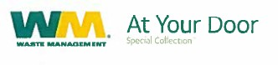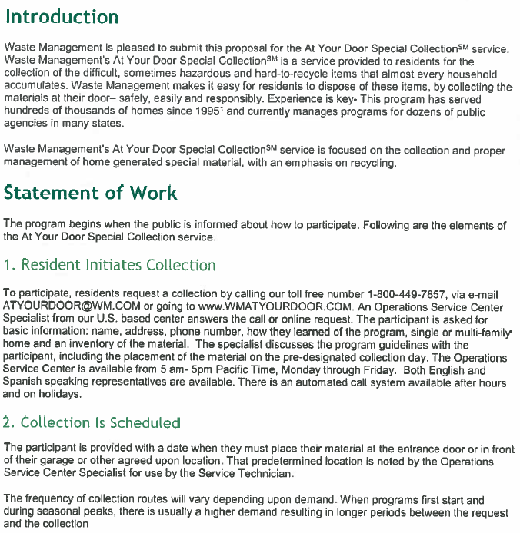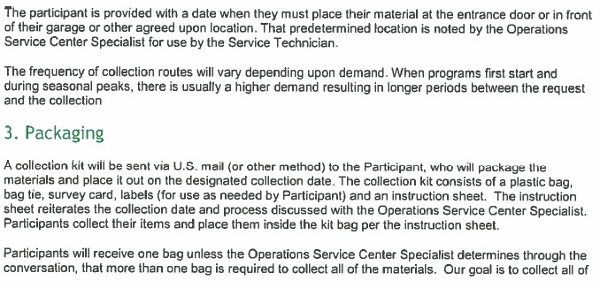

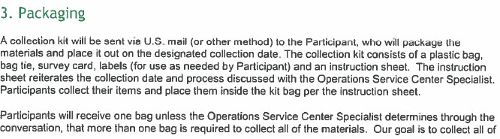

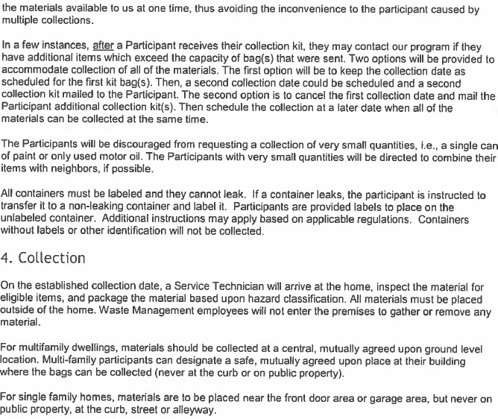

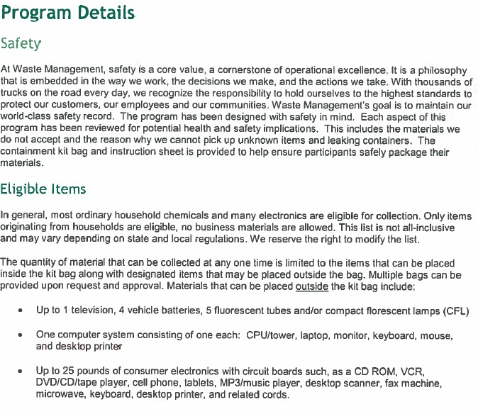

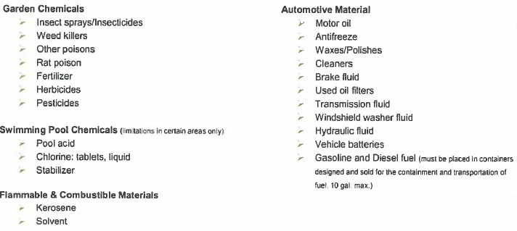

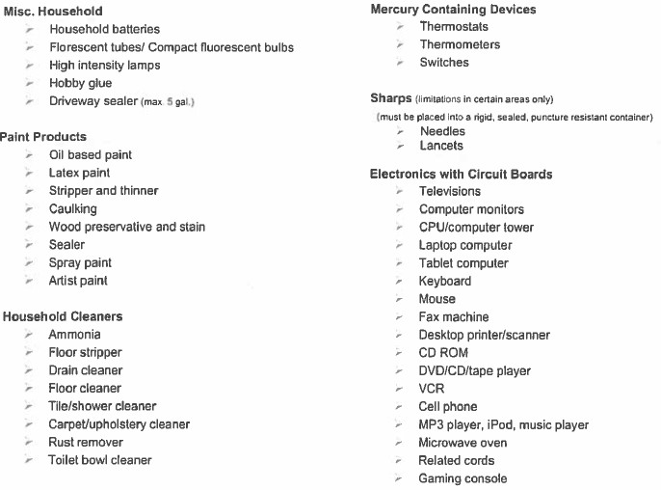

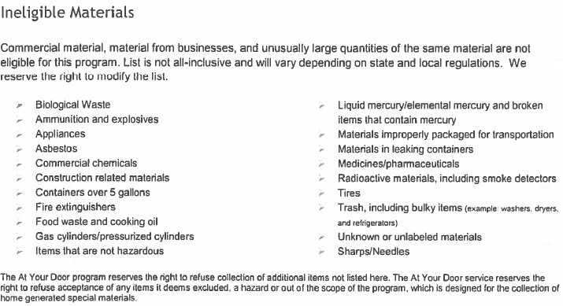

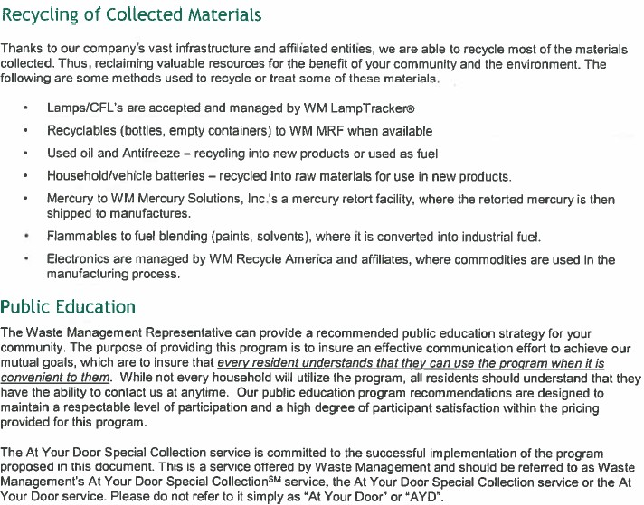

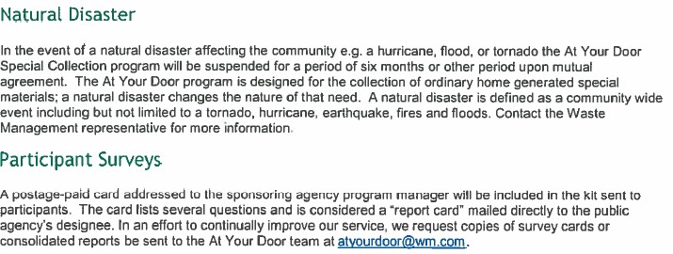

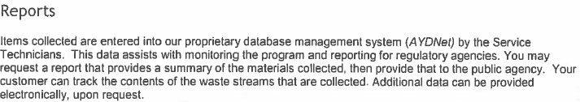

At Your Door Special Collection is a service of Waste Management. Collection services will be provided by a properly licensed/permitted subsidiary of Waste Management. ©WM Curbside, LLC. All rights reserved. At Your Door and At Your Door Special Collection are service marks of WM Intellectual Property Holdings, LLC. 2017-046

BAGSTER

BRUSH PICK-UP FLYER

SAMPLE EMERGECNY/ACT OF GOD CONTRACT