ORDINANCE NUMBER: 525-u-2021

AN ORDINANCE of the city council of the city of universal city, texas, REPEALING ordinances 525 thru ordinance 525-T-2019 (cITY CODE OF ORDINACNES CHAPTER 2-3, section 2-3-1 THRU SECTION 2-3-29) IN THEIR ENTIRETY AND adopting new provisions regarding the collection and disposition of solid waste and recyclable material in the city; Establishing a city-wide collection, transportation and disposal program; authorizing execution of a comprehensive AGREEMENT granting waste management of texas, inc. aN EXCLUSIVE franchise to operate a SOLID WASTE COLLECTION AND DISPOSAL service in the city of universal city, TEXAS; ESTABLISHING PENALTIES NOT TO EXCEED $2000.00 PER OFFENSE; PROVIDING THAT THIS ORDINANCE SHALL BE CUMULATIVE; PROVIDING FOR SEVERABILITY; and providing for an effective date

**WHEREAS,** the City of Universal City, Texas (“City”) is a Texas Home Rule City possessing the full power of local self-government pursuant to Article 11, Section 5 of the Texas constitution, Section 51.072 of the Texas Local Government Code, and the City’s Home Rule Charter; and

**WHEREAS,** the City finds it is necessary to regulate the collection, conveyance, transportation and disposal of residential, household, commercial and industrial solid wastes within the city limits of Universal City, Texas to insure the safety and well-being of the city and its citizens and to protect environmental resources including soil, air and water; and

**WHEREAS,** the City is responsible to protect its citizens against nuisances derived from solid waste by providing solid waste handling services including, but not limited to, recycling and the collection, transfer and disposal of solid waste; and

**WHEREAS,** pursuant to Chapter 363 of the Texas Health and Safety Code, the City is authorized to determine all aspects of solid waste handling which are of local concern, including, but not limited to, frequency of collection, means of collection and transportation, level of services, charges and fees, and nature, location and extent of providing solid waste handling services; and

**WHEREAS,** pursuant to Texas Health and Safety Code Section 364.033, the City is authorized to contract with a private contractor to furnish solid waste collection, transportation, handling, storage, or disposal services; and

**WHEREAS,** Local Government Code Section 252.022(a)(2) provides that a purchase necessary to preserve or protect the public health or safety of the city’s residents is excepted from the competitive purchasing requirements; and

**WHEREAS,** the City Council of the City of Universal City has determined that itis in the public interest for the City to grant an exclusive franchise to provide for the satisfactory and

efficient service to maintain safe and sanitary conditions within the City; and

**WHEREAS,** the City Council has determined that it is in the best interest of the City to grant such franchise to Waste Management of Texas, Inc. (“Contractor”) and authorizes entering into an Agreement with Contractor granting an exclusive franchise beginning 01 September 2021, and concluding July 31, 2026, to provide for the satisfactory and efficient service to maintain safe and sanitary conditions within the City; and

**WHEREAS,** the Agreement establishes rates for collection of solid waste for all residences and businesses in the City; and

**WHEREAS,** since the inception of the franchise granted to Waste Management by the City in Ordinance 525, continuing with several amendments to the contract ending with Ordinance 525-T-2019, the City Council now believes it in the best interests of the City to adopt regulations as prescribed herein.

**NOW, THEREFORE, BE IT ORDAINED BY THE CITY COUNCIL OF THE CITY OF UNIVERSAL CITY, TEXAS:**

**SECTION 1. Recitals.** All the above premises are found to be true and correct legislative determinations and are hereby incorporated into the body of this Ordinance as if copied in their entirety.

**SECTION 2. Solid Waste Program.** City of Universal City’s solid waste collection, transportation and disposal program is hereby established for all residents and businesses of the City of Universal City, Texas.

**SECTION 3. Code of Ordinances Amended.** The Code of Ordinances of the City of Universal City, Part II, Chapter 2-3, Section 2-3-1 thru Section 2-3-29 is hereby amended by deleting said sections in their entirety and replacing it with new Chapter 2-3, Section 2-3-1 thru Section 2-3-14 including Schedules A-C as provided in the attached **EXHIBIT A**, incorporated fully herein.

**SECTION 3. The Agreement.** The City Council hereby grants the exclusive franchise for solid waste collection, transportation and disposal to Waste Management, Inc. as provided in the Agreement attached hereto as **EXIBIT B**,incorporated fully herein.

**SECTION 4. Authorization.** The City Manager is hereby authorized and directed to take all other steps reasonably necessary to facilitate the purpose of this ordinance.

**SECTION 5. Continuation clause.** All provisions of the Code of Ordinances of the City of Universal City not herein amended or repealed shall remain infull force and effect.

**SECTION 6. Repealer clause.** All other ordinances or parts of ordinances in conflict herewith are hereby repealed to the extent that they are in conflict.

**SECTION 7**. **Severability clause**. If any provisions of this ordinance shall be held void or unconstitutional, it is hereby provided that all otherparts of the same which are not held void or unconstitutional shall remain in full force and effect.

**SECTION 8.** This Ordinance shall be construed shall be construed and enforced in accordance with the laws of the State of Texas and the United States of America.

**SECTION 9.** It is officially found, determined, and declared that the meeting at which this Ordinance is adopted was open to the public and public notice of the time, place, and subject matter of the public business to be considered at such meeting, including this Ordinance, was given, all as required by Chapter 551, as amended, Texas Government Code.

**SECTION 10. Effective Date.** Thisordinance will take effect upon its passage, approval and publication as provided by law.

**PASSED, on first reading** by the City Council of the City of Universal City on this the 3rd day of August 2021.

**PASSED AND APPROVED in substantial form, on second reading** by the City Council of the City of Universal City on this the 17th of August 2021.

UNIVERSAL CITY

______________________________

John Williams, Mayor

Attest: Approved as to form:

_________________________ _______________________________

Kristin Mueller, City Clerk Matthew J. Longoria, City Attorney

ACCEPTANCE: This Ordinance franchise agreement is hereby accepted in all things by the Contractor of the City of Universal City this 17th day of August 2021.

**Waste Management of Texas, Inc**

__________________________________

By JAMES C. FISH JR.

President and Chief Executive Officer

**EXHIBIT A**

**Chapter 2-3 - GARBAGE AND TRASH COLLECTION AND DISPOSAL of the City of Universal City Code of Ordinances is hereby amended as follows:**

Sec. 2-3-1. – Solid Waste Program Established.

The City’s solid waste collection, transportation and disposal program is hereby established for all residents and businesses of the City of Universal City, Texas.

Sec. 2-3-2. – Purpose.

The accumulation of garbage, recyclable material, rubbish, brush and other refuse constitutes a public nuisance, a health hazard, a fire hazard and a safety hazard. Therefore, it shall be required that owners and tenants of private residences, private commercial buildings and businesses, and the occupants of all private noncommercial buildings which accumulate refuse, deposit their garbage, rubbish, brush, and other refuse for removal by the agent designated by the city. Such owners, renters and occupants shall maintain the premises of the buildings and property free of accumulations of all other waste materials and nuisance materials. Such owners, renters and occupants shall not allow materials intended for recycling to create a nuisance on the premises of buildings and properties. All waste materials shall be disposed of in a place and by methods deemed appropriate by the City. The purpose of this chapter is to provide for a method of collecting and disposing of garbage, recyclable material, rubbish, brush, and other refuse, and to maintain neighborhood quality and aesthetics and maintenance of property values by providing for the general health and welfare.

Sec. 2-3-3. – Services of Franchisee Required.

It is hereby prohibited for any individual to utilize the services of any individual or corporation for purposes of residential solid waste collection other than the City’s designated solid waste franchisee. Every residential occupant shall subscribe to the services of the franchisee having the exclusive franchise for collection and disposal service with the City. It is declared to be unlawful for the occupant of any of the premises described in this section to fail or neglect to provide for the removal of solid waste as required under this Chapter.

Sec. 2-3-4. - Definitions.

For the purpose of this chapter, certain terms and words are hereby defined. Terms and words not specifically defined shall be construed with common usage and meaning or as defined by state or federal agencies having oversight jurisdiction:

**At Your Door (AYD) Program**: A special collection service provided by Contractor or its affiliate to residents for the collection of difficult, sometimes hazardous and hard-to-recycle items generated by a household.

**Bag:** A plastic sack no more than 33 gallons in size designed to store Waste with sufficient wall strength to maintain physical integrity when lifted by the top to which a Customer may affix a Pink Tag and place curbside for collection.

**Brush**: Tree, shrub, grass, brush trimmings, leaves, limbs, shrubbery and other yard waste and green material securely tied together to form an easily handled bundle or placed in that is generated by or at Residential Unit Customer locations and placed curbside for collection. Limbs shall not exceed four feet (4’) in length or six inches (6”) in diameter.

**Bulk Waste**: Furniture, bicycles (without tires), refrigerators that have CFCs removed by a certified technician, stoves, and other oversized wastes which are customary to ordinary housekeeping operations of a Residential Unit and whose large size precludes or complicates its handling by normal solid waste collection, processing or disposal methods.

**City**: The City of Universal City, Texas.

**Commercial Unit**: All commercial businesses and establishments, including, but not limited to, stores, offices, restaurants, warehouses, and related facilities, premises, locations or entities, public or private, within the corporate limits of the City.

**Commercial Waste**: All Garbage, Waste, and Rubbish generated by a Commercial Unit, excluding Unacceptable Waste.

**Construction Debris**: Waste building materials resulting from construction, remodeling, repair, or demolition operations that are directly or indirectly the by-products of construction work or that result from demolition of buildings or other structures, but specifically excluding land-clearing debris, yard debris, or used asphalt, asphalt mixed with dirt, sand, gravel, rock, concrete, or similar materials.

**Contract Administrator**: That person, or his designee, designated by the City to administer and monitor the provisions of this Chapter.

**Contractor**: The entity or agent designated and authorized as exclusive Franchisee by the City to administer this Chapter.

**Customer**: The owner or tenant of a Residential Unit, Industrial Unit, or Commercial Unit located within the City, and identified by the City as being eligible for and in need of the services provided by the Contractor under this Chapter.

**Dead Animals**: Animals or portions thereof that have expired from any cause except those slaughtered or killed for human use.

**Disposal Site**: A duly permitted sanitary landfill selected by Contractor.

**Dumpster**: Metal receptacle designed to be lifted and emptied mechanically for use only at Commercial Units or Industrial Units.

**Excess Garbage, Waste or Rubbish**: Anys garbage, waste, or rubbish placed outside of a polycart and not bearing a Pink Tag shall be deemed excess Garbage, Waste or Rubbish and will not be picked up. If a Residential Unit is found to have excessive trash on three (3) or more trash or recycling days in a six (6) month period, then the City has the authority to order an additional Polycart for that Residential Unit and add it corresponding Residential Unit customer account.

**Garbage**: Solid Waste consisting of putrescible or animal and vegetable waste materials resulting from the handling, preparation, cooking, and consumption of food, including waste materials from markets, storage facilities, handling and sale of produce and other food products, and all Dead Animals of less than ten pounds (10 lbs.) in weight, except those slaughtered for human consumption.

**Hazardous Waste**: Any material or waste identified or listed as a hazardous waste by the administrator of the Environmental Protection Agency under the Federal Solid Waste Disposal Act as amended by RCRA, 42 U.S.C. §6901, et. seq., as amended.

**Industrial Unit**: All industrial businesses and establishments, including manufacturing facilities, temporary construction sites, and other premises, locations or entities, public or private, within the corporate limits of the City.

**Industrial Waste**: Solid Waste resulting from or incidental to any process of industry, manufacturing, construction, demolition, mining or agricultural operations. Industrial Waste includes Construction Debris, but excludes Unacceptable Waste.

**Light Commercial Unit**: A retail or light commercial type of business, which generates no more than one (1) cubic yard of Garbage, Rubbish, and Refuse per week, excluding Unacceptable Waste.

**Medical Waste**. Waste generated by health care related facilities and associated with health care activities, not including Garbage or Rubbish generated from offices, kitchens, or other non-health-care activities. The term includes Special Waste from health care-related facilities which is comprised of animal waste, bulk blood and blood products, microbiological waste, pathological waste, and sharps as those terms are defined in 25 TAC §1.132 (relating to Definitions).

**Non-Recyclables:** Any materials in the Single Stream Materials that are not Recyclables.

**Pink Tag:** A tag or adhesive sticker developed, produced, and sold by the City to Residential Customers to affix on to a bag into which Waste has been deposited and then the bag has been placed curbside for Contractor to collect on that resident’s regular collection day. Pink tag use is restricted to Residential Waste or Brush in a Bag as herein defined. Pink tags shall not be used for Medical Waste, Special Waste, Bulky Waste, or Construction Debris as herein described. One (1) Pink Tag is required for each and every Bag. Bags without a Pink Tag will not be picked up and be deem as Excessive Garbage, Waste, or Rubbish.

**Polycart**: A Contractor owned rubber-wheeled receptacle with a maximum capacity of 90 - 96 gallons constructed of plastic, metal and/or fiberglass, designed for automated or semi-automated solid waste or recyclables collection systems, and having a tight-fitting lid capable of preventing entrance into the container by small animals.

**Recyclable Materials or Recyclables**: A material that has been recovered or diverted from the non-hazardous waste stream for purposes of reuse, recycling, or reclamation, a substantial portion of which is consistently used in the manufacture of products that may otherwise by produced using raw or virgin materials. Recyclable Material is not solid waste. However, Recyclable Material may become Solid Waste at such time, if any, as it is abandoned or disposed of rather than recycled, whereupon it will be solid waste, with respect to the party actually abandoning or disposing of such material.

**Residential Unit:** A residential dwelling, such as a home, townhouse or condominium unit, within the service area of the City occupied by a person or group of persons comprising not more than four families and serviced through the collection of Polycarts. A Residential Unit shall be deemed occupied when either water or domestic light and power services are being supplied thereto.

**Residential Waste**: All Garbage, Rubbish and Waste generated by a Customer at a Residential Unit, excluding Unacceptable Waste and Construction Debris generated by a Third-Party Provider.

**Rubbish**: Nonputrescible Solid Waste (excluding ashes), consisting of both combustible and noncombustible waste materials. Combustible rubbish includes paper, rags, cartons, wood, wood shavings, furniture, rubber, plastics, yard trimmings, leaves, brush or similar materials; noncombustible rubbish includes glass, crockery, tin cans, aluminum cans, metal furniture, and similar materials that will not burn at ordinary incinerator temperatures (1,600 degrees Fahrenheit to 1,800 degrees Fahrenheit).

**Single Stream Materials**: means all materials deposited by a Customer in the Customer’s Recycling Cart, including any Recyclables and Non- Recyclables.

**Solid Waste or Waste**: Non-hazardous solid waste generated by a Customer at a Residential Unit to be collected by Contractor under this Ordinance. Solid Waste excludes Unacceptable Waste.

**Special Waste**: Waste that requires special handling and management due to the nature of the waste, including, but not limited to, the following: (A) containerized waste (e.g. a drum, barrel, portable tank, box, pail, etc.), (B) waste transported in bulk tanker, (C) liquid waste, (D) sludge waste, (E) waste from an industrial process, (F) waste from a pollution control process, (G) residue and debris from the cleanup of a spill or release of chemical(s), or (H) any other waste defined by applicable law, rule or regulation as "Special Waste".

**Third-Party Provider**: A commercial business enterprise or third party that provides any type of services to Residential Units or construction sites.

**Unacceptable Waste**: Any waste or material that (i) the acceptance and handling of which by Contractor would cause a violation of any permit, condition, legal or regulatory requirement, (ii) substantial damage to Contractor's equipment or facilities, or (iii) contains information (in hard copy or electronic format) that is protected or regulated under any local, state or federal privacy or data security laws, including without limitation, the Health Insurance Portability and Accountability Act (HIPAA), or (iv) presents a danger to the health or safety of the public or Contractor's employees, and/or (v) is or contains Hazardous Waste, Special Waste, untreated Medical Waste, Dead Animals weighing ten pounds (10 lbs.) or greater, or (vi) is or contains solid or dissolved material in domestic sewage, or solid or dissolved material in irrigation return flows, or industrial discharges subject to regulation by permit, or (vii) is soil, dirt, rock, sand, and other natural or man-made inert solid materials used to fill land if the object of the fill is to make the land suitable for the construction of surface improvements, or (viii) results from activities associated with the exploration, development, or production of oil or gas or geothermal resources.

**Unusual Accumulations or Overage**: As to Residential Units, any Waste placed curbside for collection or placed outside, on top of or sticking out of a Polycart, other than Bags with a Pink Tag affixed to them. As to Commercial Units and Industrial Units, (i) any Waste or other material placed on top of or located outside the Dumpster, Roll- off Bin or Compactor regularly used for such collection service or (ii) in excess of the applicable weight limits or intended capacity such that the lid will not completely close.

Sec. 2-3-5. – Collection Services.

**A. Residential Collection**: A Residential Unit Customer may request an additional Polycart and Contractor must provide an additional Cart at the rate set forth in Schedule A. A Residential Unit Customer may purchase a Pink Tag from the City and affix the Pink Tag to a Bag of Waste. Contractor will collect properly placed Bags that have a Pink Tag affixed thereto on the Residential Unit Customer’s regular collection day.

1. Contractor shall collect Residential Waste generated at a Residential Unit and placed in that Residential Unit’s Waste Polycart two times per week, but not less than three days between collection times within the same week. The Contractor shall not be obligated to collect any Waste not properly contained in the Customer’s Waste Polycart.
2. Construction Debris generated at a Residential Unit by the owner or tenant of that Residential Unit, and not using the services of a Third-Party Provider, shall be subject to the Bulky Waste limitations set forth in this Ordinance. Any Waste or Bulky Waste generated by an owner or tenant, or a Third-Party Provider is Commercial Waste and Contractor has no obligation to collect those materials.

**B. Brush Collection**: Contractor shall provide quarterly or four times per year collection service

to Residential Units for collection of Brush. Contractor and City shall agree on the dates/times for such services and shall mutually be responsible for notifying residents of collection dates. Contractor agrees to collect up to, but not to exceed, a total of six (6) cubic yards of Brush from each Residential Unit.

Contractor shall have no obligation to collect any Brush in excess of the above volume, Brush

shall be placed within three (3) feet of the curb, swale, paved surface of the roadway, closest

accessible roadway, or other location agreed to by Contractor and Customer,

that will provide safe and efficient accessibility to Contractor's collection crew and vehicle

Collection of Curbside Residential Unit Bulky Waste is not included. Construction Debris generated by a Third-Party Provider hired by a Residential Unit Customer and generated and/or located at that Residential Unit is considered and shall be treated as Commercial Waste.

**C. Residential Door-to-Truck Service:** Contractor will provide, at no cost to the City or the Residential Customer, Residential Door-To-Truck waste collection for up to 20 Residential Customers that the City determines have demonstrated a need or hardship necessitating this special service. The City has sole responsibility for determining which Residential Unit Customers qualify for this special service. The City will provide Contractor with a complete list of qualifying Customers’ addresses each time a modification is made. Door-to-Truck collection service means the Customer places their Waste Polycart near their garage or carport rather than curbside. Contractor may refuse to provide this service if the location of the Polycart exceeds 150 feet from the curb line or edge of pavement and no such service will be provided for Bulky Waste or Brush collection.

**D. Residential Recyclables Collection:**

1. Contractor shall collect Residential Unit Recyclables once per week, per an agreed upon schedule with the City. Residential Unit Customers must place all Recyclables into the Recycling Cart. Contractor shall not be required to collect any Recyclable Materials that are not placed in a Recycling Cart. In addition, Contractor shall not be required to collect Recyclable Materials if the Customer does not segregate the Recyclable Materials from the remainder of the Residential Waste.
2. **Recyclables Specifications**: The following are Recyclables that Customers may deposit into the Recyclables Carts. To be acceptable, the Recyclables must be dry, loose (not bagged), unshredded, empty and include only the following:

|  |  |
| --- | --- |
| Aluminum cans | Newspaper |
| PET bottles with the symbol #1 – with screw tops only | Mail |
| HDPE plastic bottles with the symbol #2 (milk, water bottles detergent, and  shampoo bottles, etc.) | Uncoated paperboard (ex. cereal boxes; food and snack boxes) |
| PP plastic bottles and tubs with symbol # 5 - empty | Uncoated printing, writing and office paper |
| Steel and tin cans | Old corrugated containers/cardboard (uncoated) |
| Glass food and beverage containers – brown, clear, or green | Magazines, glossy inserts and pamphlets |

**Non-Recyclables include, but are not limited to, the following:**

|  |  |
| --- | --- |
| Plastic bags and bagged materials (even if containing Recyclables) | Microwavable trays |
| Porcelain and ceramics | Light bulbs, Mirrors |
| Window or auto glass | Coated cardboard |
| Soiled paper, including paper plates, cups and pizza boxes | Plastics not listed above including but not limited to those with symbols #3, #4, #6, #7 and unnumbered plastics, including utensils |
| Expanded polystyrene | Coat hangers |
| Glass and metal cookware/bakeware | Household appliances and electronics |
| Hoses, cords, wires | Yard waste, construction debris, and wood |
| Flexible plastic or film packaging and multi-laminated materials | Needles, syringes, IV bags or other medical supplies |
| Food waste and liquids, containers containing such items | Textiles, cloth, or any fabric (bedding, pillows, sheets, etc.) |
| Excluded Materials or containers which contained Excluded Materials | Napkins, paper towels, tissue, paper plates, paper cups, and plastic utensils |
| Any paper Recyclable materials or  pieces of paper Recyclables less than 4” in size in any dimension | Propane tanks, batteries |
| Cartons | Aseptic Containers |

1. **Delivery Specifications.** Residential Unit Customers shall deposit only the Recyclables listed above into their Recyclables Carts. If a load of material does not meet these specifications, the Recycling Facility may reject the load and the City may be charged for the resulting transportation, handling, and disposal costs for the Non- Recyclables. The Recycling Facility or Contractor has the right to dispose of all residue, contamination, and Non-Recyclables resulting from or remaining after the processing of the materials collected from the Recyclables Carts. The City acknowledges that Contractor may face unforeseen charges or increases based on the recycling market, the quality of the materials collected within the City, and/or uncontrollable circumstances, including without limitation, changes in law, and the City agrees to pay these charges so long as Contractor provides the City with written documentation explaining or justifying the increase prior to the City’s payment.
2. **Recycling Market Changes:** The market for Recyclables continues to evolve and is volatile. As such, Contractor cannot make any representations as to the marketability of the Recyclables, and when no reasonable commercial market exists for a commodity, Contractor and/or the Recycling Facility reserves the right to dispose of that material. Contractor also reserves the right to add or delete materials from the list of Recyclables based upon requests or demands from the Recycling Facility, changes in market conditions, uncontrollable circumstances, governmental restraint, or changes in laws, rules, regulations, or ordinances, and Contractor will provide written notice to the City of those changes. The Recycling Facility reserves the right to dispose of particular Recyclables when no reasonable commercial market exists for a commodity. The City and Contractor may agree to amend the terms of the recycling portion to reflect the current market or legal conditions.

**E. Carts/Polycarts/Placement**:

1. Contractor agrees to provide one (1) Waste Polycart and (1) Recycling Polycart to each Residential Unit for the deposit of Waste and Recyclables. The Carts shall be placed by the Customer of a Residential Unit in a location that is readily accessible to Contractor and its collection equipment, not to exceed three (3) feet from the curb or edge of the travelled portion of the street, road or alley, and not to be located in a manner that will block the driveway or mailbox or otherwise inhibit proper servicing. The City shall aid Contractor in resolving problems of Cart location by the Customer. Customers shall not overload Carts, and the Carts shall be loaded such that the lids shall close securely.
2. Contractor shall not be required to collect (i) any Residential Waste or Recyclables that are not placed in a Polycart, (ii) any Residential Waste or Recyclables from a Polycart that is overloaded or whose lid cannot fully close, or (iii) a Polycart that is not properly placed curbside. Contractor shall have no obligation to collect Unusual Accumulations/Overage and may charge for the collection of same so long as Contractor provides a digital image or photograph of the Overage to the Residential Unit Customer upon request.
3. The Carts furnished by the Contractor hereunder shall remain the property of Contractor, and the Customer will have no interest in the Carts. The Carts shall remain at the location of the Residential Unit where delivered by Contractor. If a Cart is damaged beyond repair, the Contractor must provide a replacement Cart to the Residential Unit location at no charge. Any Cart removed from, lost or missing from a Customer location may be deemed lost, and Contractor must provide a replacement Cart at a cost of $70.00 per Cart to the City. The City may pass through the Contractor’s replacement Cart charge to the Residential Unit Customer at the City’s option.

**F. Residential Household Special Waste Collection Program**: Contractor agrees to provide a

residential household hazardous waste collection service pursuant to the terms set forth in

**Schedule C**, the At-Your-Door Program.

**G. Commercial and Industrial Unit Collection**: Contractor shall have the exclusive right to

collect and transport Commercial Waste from the Commercial Units and Industrial Waste from

the Industrial Units, respectively, utilizing Dumpsters, Compactors or Roll Off Bins, at such frequency as shall be reasonably requested and agreed to between the Customer and Contractor. The Dumpster, Compactor or Roll Off Bin shall be located on a concrete pad to accommodate equipment and at a location reasonably acceptable to Contractor. Contractor may, at its sole option, require Commercial or Industrial Unit Customers to enter individual contracts with Contractor, subject to the terms of this Agreement. If additional Roll Off Bins, Compactors, Dumpsters or collection services are needed by Commercial or Industrial Unit Customers beyond what Contractor can provide, the City and Contractor, upon mutual written agreement, may allow Contractor to use a third party to assist Contractor in providing the needed waste equipment or services hereunder on a temporary basis.

**H. Unusual Accumulations Collection/Overage**: Contractor shall have no obligation to collect Unusual Accumulations/Overage and may charge for the collection of same so long as Contractor provides a digital image or photograph of the Overage to the Commercial or Industrial Unit Customer upon request.

**I. Unacceptable Waste**: Contractor shall not be obligated to collect any Unacceptable Waste. Title to Unacceptable Waste shall not pass to Contractor, and liability for any Unacceptable Waste shall remain with the generator of such material.

**J. Services Provided to City or City Facilities:**

1. The Contractor will provide, at no charge, Waste collection services two times per week, but not less than three days between collection times within the same week, at the City facilities listed in Schedule B. The Waste containers provided at each City facility will be of the size and type appropriate to the volume and characteristics of the Waste and as set forth in Schedule B. Additional or new City facilities or buildings will only be serviced by Contractor at no charge upon the mutual written agreement of both parties.
2. Contractor will provide to the City, at no additional charge, two (2) thirty cubic yard Roll-Off container at a location determined by the City Public Works Department and agreed to by Contractor. Contractor will provide a maximum of 180 prescheduled pulls each calendar year at no charge to the City. These 180 Roll-Off pulls must be used during each calendar year and may not be accumulated and rolled into the following calendar year. The weight of the Roll-Off shall not exceed eight (8) tons per pull. The City is required to electronically notify the Contractor of the requested pull(s) for the 30 cubic yard Roll-Off via the Contractor’s PSS Customer Service Team. Contractor shall charge and the City agrees to pay the rate set forth in Schedule A for any Roll-Off load heavier than the eight-ton limit, provided Contractor notifies the City within three (3) business days of an overweight load. Otherwise, there will be no additional charge for over-limit loads. Additional pulls will be charged to the City per the then-current rates in Schedule A.
3. Contractor will provide special collection services daily at designated locations during the City's annual fall and spring cleanup. Six (6) forty-cubic-yard roll-off containers will be provided to the City for each such annual fall and spring cleanup where only residential Bulky Waste will be collected. Container and pickup service will be at no cost to the City. Such fall and spring clean-ups shall not exceed two (2) weeks each and number of roll-off container pulls shall not exceed 72 for each clean-up. The City will be charged the current applicable rate in Schedule A for any load heavier than the eight-ton limit, provided Contractor notifies the City within three (3) business days of an overweight load. Otherwise, there will be no additional charge for over-limit loads. Additional pulls will be charged to the City at the then-current rate in Schedule A. Contractor shall have no obligation to haul any roll-off that contains construction, commercial, or industrial waste. The City will be requested to remove such waste from the roll-off. If the City is unable to remove the waste, Contractor has the right to transport and dispose of the roll-off contents at the applicable rate for such waste type.

Sec. 2-3-6. – Collection Operations.

**A. Hours of Operation**: Collection of Residential Waste and Light Commercial Waste shall begin no earlier than 7:00 A.M. and may not extend beyond 6:00 P.M. Collection of Commercial Waste or Industrial Waste shall begin no earlier than 6:00 A.M. and may not extend beyond 6:00 P.M. No collections shall be made on Sunday.

**B. Routes of Collection**: Collection routes shall be established by the Contractor as reasonably approved by City. City shall provide Contractor with maps of the City containing sufficient detail for Contractor to design collection routes. Contractor shall provide to the City route maps for approval by the City, which approval shall not be unreasonably withheld.

**C. Holidays**: The following are holidays for purposes of this Ordinance:

|  |  |  |
| --- | --- | --- |
| New Year's Day | Labor Day | Thanksgiving Day |
| Independence Day | Memorial Day | Christmas Day |

Contractor may decide to observe any or all of the above-mentioned holidays by suspension or collection service on the holiday, but the Contractor is responsible for providing make-up collection for residential routes that occur on specified holidays. Make-up days are the next business day following the holiday and every remaining route day scheduled for that week will be pushed a day.

**D. Complaints**: Customer complaints shall be directed by the City to Contractor, and Contractor shall promptly resolve any complaint based on the nature of the complaint. Contractor shall be responsible for maintaining a log of complaints based on the information provided to Contractor by the City, and shall provide the City, on a monthly basis, with copies of all complaints indicating the date and hour of the complaint, nature of the complaint, and the manner and timing of its resolution. Any alleged missed pickups will be investigated and, if such allegations are verified, Contractor shall arrange for collection on the next business day after receipt of such complaint. If the missed pickup is a result of Customer related acts or omissions, the City shall take appropriate action to cause such Customer to subsequently properly set out such Waste.

**E. Collection Equipment**: Contractor, at its sole cost and expense, agrees to furnish, all trucks, equipment, machines, and labor which are reasonably necessary to adequately, efficiently, and properly collect and transport Waste from Customers serviced by Contractor in accordance with this Ordinance.

**F. Disposal**: The Contractor shall deliver Waste collected to a duly permitted Disposal Site operated in compliance with rules stipulated by the applicable state agency and/or the U.S. Environmental Protection Agency.

**G. Spillage**: The Contractor shall not be responsible for scattered Refuse unless the same has been caused by Contractor, in which case all scattered Refuse shall be picked up immediately by Contractor.

**H. Vicious Animals**: Employees of the Contractor shall not be required to expose themselves to the dangers of vicious animals in order to accomplish Refuse collection service. Contractor shall immediately notify the City, in writing, of such condition and of his inability to make collection.

**I. Protection From Scattering**: Each Contractor vehicle shall be equipped with a cover which may be net with mesh not greater than one and one-half (1-1/2) inches, or tarpaulin, or fully enclosed metal top to prevent leakage, blowing or scattering of refuse onto public or private property.

**J. Point of Contact**. All dealings and contacts between Contractor and the City shall be directed between Public Sector Solutions Manager of Contractor, or such other individual identified by Contractor, and the Contract Administrator designated by the City.

Sec. 2-3-7. – Billing.

1. City shall provide billing and bill collection services for Residential Units. Within twenty-one (21) days of the end of each month during which collection services are provided by Contractor hereunder, Contractor shall submit to the City an invoice setting forth sums due by the City to Contractor for services rendered for the prior month. The City shall notify, in writing, and request that Contractor suspend services to any Residential Unit Customer that has failed to pay the City for Waste or Recyclables collection services, and Contractor may suspend service to such delinquent Customer until notified by the City to resume such services. The City’s franchise, billing, or administrative fees, if any, will not be included in the Contractor’s invoices to the City for services provided to Residential Units. The City shall include in its bills sent directly to Residential Units any City franchise, billing, or administrative fees and shall retain those fees.
2. Contractor shall provide billing and bill collection services for all Commercial and Industrial Unit Customers including Light Commercial Customers, that use Polycarts, Dumpsters, Compactors, or Roll-Off Bins. Within 21 days of the end of each month during which collection services are provided by Contractor hereunder, Contractor shall submit an invoice to each Commercial and Industrial Customer.
3. Contractor shall include in its invoices to the Customer the City’s franchise fee of ten percent (10%) (“Franchise Fee”) for Commercial and Light Commercial Customers that use Polycarts or Dumpsters, along the City’s franchise fee of 15 percent (15%) for Industrial Compactors or Roll-Offs. The Franchise Fee payments actually received by Contractor from Customers shall be paid by the Contractor to the City within thirty (30) days after the last day of the month of Contractor’s actual receipt of such monies. The rates set forth in **Schedule A** for Commercial, Light Commercial, and Industrial Unitsinclude the City’s Franchise Fee. The rates set forth in Schedule A for Residential Units DOES NOT include the City’s 10% franchise fee. The Franchise Fee shall not be added to and/or be assessed upon any state or local sales tax or other governmental fees, such as the state of Texas disposal fee, or the Franchise Fee itself.
4. Invoices sent to Commercial, Light Commercial and Industrial Unit Customers by Contractor shall be paid within thirty (30) days after receipt of such invoice by Customer or in accordance with each individual contract between Customer and Contractor, if any. All past due invoices shall bear interest at the highest rate permitted by law. Contractor may suspend service to any Customer that is delinquent in payment directly to Contractor. If Contractor suspends service to a Customer for failure to timely pay Contractor’s invoices, Contractor has the right to charge a service reactivation fee and/or finance charges or late payment fees if such service to the Customer is reinstated.

Sec. 2-3-8. – Modification to rates.

**A. CPI Adjustment**. Base Rates for services may be adjusted annually by eighty-five percent (85%) of the average monthly percentage increase that the Consumer Price Index, US City Average for All Urban Consumers, Garbage and Trash, Not Seasonally Adjusted, Base Period December 1983 = 100 (published by the United States Bureau of Labor Statistics, Consumer Price Index) (the “C.P.I.”) has increased over the 12 most recently published months. The C.P.I. published on the first Monday prior to the end of June (or the first business day thereafter if such Monday is a Federal Holiday) shall be used to determine the monthly percentage increase change. The average will be determined by calculating the percentage increase change in the CPI each month during the applicable 12-month period. Once that average is determined, then the average increase change for the 12- month period for the prior year will be subtracted and that sum will be multiplied by 85%. The product shall be the CPI adjustment component of the annual modification to Base Rates. In the event the U.S. Department of Labor, Bureau of Labor Statistics ceases to publish the C.P.I., the parties hereto agree to substitute another equally authoritative measure of change in the purchasing power of the U.S. dollar as may be then available so as to carry out the intent of this provision. The percentage increase change shall be multiplied by 85% and the product thereof shall be the “CPI Adjustment Component” of the annual modification to Base Rates.

**B. Fuel Adjustment**. Base Rates may be adjusted by 15% of the average percentage increase or decrease in the price of compressed natural gas determined by the Energy Information Administration of the US Department of Energy (“EIA/DOE”)’s Natural Gas Commercial Price-Texas Index during the applicable 12-month time period. The average will be computed by calculating the percentage change in the EIA/DOE price each month during the applicable 12-month period. Once that average is determined, then the average change for the 12-month period during the prior year will be subtracted and that sum will be multiplied by 15%. product thereof shall be the fuel adjustment component” of the annual modification to Base Rates.

**C. Additional Adjustments**. Contractor may also be entitled to an increase in Base Rates from time to time during the term of this Agreement to offset any substantiated change in conditions which increase the Contractor’s costs, including but not limited to, increases in disposal costs, increases in landfill fees, changes in the ordinances under which the Contractor is to operate, or changes in federal, state or local laws, rules or regulations. Documentation of such increases shall be submitted to the City upon the City’s request.

Sec. 2-3-9. – Franchisee Insurance Requirements.

Contractor shall procure and maintain insurance against claims for injuries to persons or damages to property, which may arise from or in conjunction with the performance of the work hereunder by the Contractor, its agents, representatives, employees, or subcontractors. The City shall be named as an additional insured under the policies, except for workers’ compensation, and shall have coverage for liability assumed under an insured contract. Contractor shall provide the City with a certificate of insurance reflecting the City’s additional insured status and agreeing to give the City at least 30 days’ written notice in case of policy termination. The cost of such insurance shall be borne by the Contractor.

Minimum Limits of Insurance**:**

|  |  |  |
| --- | --- | --- |
| **Type of Coverage** | **Per Occurrence Minimum** | **Aggregate Minimum** |
| Workers Compensation Employer’s Liability | Statutory  $500,000 | As required by law |
| Commercial General Liability | $1,000,000 | $1,000,000 |
| Auto Liability  Bodily Injury Property Damage | $1,000,000  $1,000,000  $ 500,000 | $1,000,000 |
| Umbrella Liability Policy | $2,000,000 | $2,000,000 |

Sec. 2-3-10. – License and Taxes.

Contractor shall obtain at its sole expense all licenses and permits required by the City and the State and shall maintain same in full force and effect.

Sec. 2-3-11 – Performance Bond.

The Contractor shall furnish a performance bond as security for the faithful performance of this Ordinance. Said performance bond will be in the amount of $20,000 and will be renewed on an annual basis. The Contractor shall pay premiums for the bond. A certificate from the surety showing that the bond premiums are paid in full shall accompany the bond. Such certificate shall be submitted to the City with the bond on an annual basis. The surety on the bond shall be a duly authorized corporate surety authorized to do business in the State of Texas.

Sec. 2-3-12. – Applicability of state law.

The provisions of this Chapter are adopted under Texas Health and Safety Code Chapters 361, 363, and 364.

1. The regulations promulgated in this chapter cover all aspects of municipal solid waste management under the authority of the State and are based primarily on the stated purpose of Vernon Texas Statue and Codes, Health and Safety Code ch. 361, as amended, hereafter referred to as the Texas Solid Waste Disposal Act. The owner or operator of a municipal solid waste landfill (MSWLF) facility shall comply with any other applicable federal rules, laws, regulations or other requirements.
2. All permits, including any special provisions therein, issued by the applicable State Department shall remain in force after the effective date of the ordinance from which this article is derived. To the extent that a standard has been changed by this article, the permittee may continue to operate under standards contained in previously issued permits, except for those requirements mandated by EPA 40 C.F.R. §§ 257 and 258, as amended, which implement certain requirements of subtitle D of the Resource Conservation and Recovery Act (RCRA). For those Federally mandated requirements, the permittee is under an obligation to apply for a change to his permit in accordance with Federal and State law, as applicable, to incorporate the required standard. Timely submission of a request for a permit change qualifies the owners or operators of existing MSWLF units for interim status. MSWLF facility owners or operators with interim status are treated as having been issued a permit modification or amendment until the Executive Director makes a final determination on the permit modification request or the commission makes a final determination on the permit amendment request. Facility owners or operators with interim status must comply with the requirements of this article upon the effective date of this article.

Sec. 2-3-13. – Enforcement.

The provisions of this Chapter shall be enforced by the Director of Public Works or his duly appointed representative, and it shall be unlawful for any person to interfere with or hinder the Director of Public Works or his duly appointed representative in the exercise of his duties under this chapter. Notwithstanding any provisions contained herein to the contrary, the Director of Public Works or his duly appointed representative are hereby granted the authority to issue citations to persons violating any provision of this article.

Sec. 2-3-14. – Offense.

(a)    Any person violating or failing to comply with any provision or requirement of this article, who continues to violate or fails to comply with same, shall also be deemed guilty of a misdemeanor and, upon conviction thereof, shall be fined in an amount not to exceed $2,000.00, such offenses listed herein being violations of the health and safety ordinance of the City. A separate offense shall be deemed committed upon each day during or on which a violation or failure to comply occurs or continues to occur. This section shall be in addition to and cumulative of the provisions for abatement by the City of any nuisance created by the violation of this ordinance and the charging of the cost of abatement of said nuisance against the owner of the property.

(b)    Notwithstanding the foregoing, any violation of any provision of this chapter which constitutes an immediate danger or threat to the health, safety and welfare of the public may be enjoined in a suit brought by the City for such purpose.

(c)    In addition to any other remedies or penalties contained herein, the City may enforce the provisions of this article pursuant to the applicable provisions of Vernon Texas Statues and Codes, Local Government Code Ch.54, which chapter provides for the enforcement of municipal ordinances.

(d)    Allegation and evidence of a culpable mental state is not required for the proof of an offense defined by this chapter.

**Acknowledgement as “Exhibit A”**

UNIVERSAL CITY

______________________________

John Williams, Mayor

Attest: Approved as to form:

_________________________ _______________________________

Kristin Mueller, City Clerk Matthew J. Longoria, City Attorney

**Waste Management of Texas, Inc**

__________________________________

By JAMES C. FISH JR.

President and Chief Executive Officer

Sec. 2-3-15. – Schedules.

# SCHEDULE A

**(Base Rates)**

|  |  |  |
| --- | --- | --- |
| **RESIDENTIAL UNITS** | **FREQUENCY OF COLLECTION** | **Base RATE** |
| 1- WM Provided 96 Gallon Waste Cart - Curbside | 2x week | $ 21.06 |
| 1- WM Provided 96 Gallon Recycle Cart - Curbside | 1x week | Included |
| Household Hazardous Waste Collection - At Your Door | Unlimited | Included |
| Brush Waste (6 CY Allowance) - Curbside | 2x year | Included |
| Bulk Waste (Fall & Spring Cleanup) - Convenience Station | 2x year | Included |
| Each Additional WM 96 Gal Cart (Trash or Recycle) | -- | $ 8.55 |
| Pink Tag/Sticker | -- | $ 1.80 |

*Residential Unit rates and charges **DO NOT** include any current or future City mandated franchise, administrative, or billing fee.

|  |  |  |  |  |  |  |  |
| --- | --- | --- | --- | --- | --- | --- | --- |
| LIGHT COMMERCIAL UNIT TRASH COLLECTION RATES PER CONTAINER PER MONTH | | | | | | | |
|  | | | | | | | |
| **Container Size / Type** | **1XWK** | **2XWK** | **3XWK** | **4XWK** | **5XWK** | **6XWK** | **EXTRA PU** |
| Poly Cart PU (1 Cart) | $ 24.98 | $ 49.84 | -- | -- | -- | -- | -- |
| Poly Cart PU (2 Carts) | $ 49.84 | $ 99.89 | -- | -- | -- | -- | -- |
| Poly Cart PU (3 Carts) | $ 74.92 | $ 149.84 | -- | -- | -- | -- | -- |
| Poly Cart PU (4 Carts) | $ 99.89 | $ 199.77 | -- | -- | -- | -- | -- |

|  |  |  |  |  |  |  |  |
| --- | --- | --- | --- | --- | --- | --- | --- |
| COMMERCIAL UNIT TRASH COLLECTION RATES PER CONTAINER PER MONTH | | | | | | | |
|  | | | | | | | |
| **Container Size / Type** | **1XWK** | **2XWK** | **3XWK** | **4XWK** | **5XWK** | **6XWK** | **EXTRA PU** |
| 2 Yard FEL Container | $ 49.36 | $ 98.72 | $148.09 | $197.98 | $246.24 | $246.31 | $ 49.36 |
| 3 Yard FEL Container | $ 74.03 | $ 125.87 | $22.13 | $296.16 | $370.21 | $310.99 | $ 74.03 |
| 4 Yard FEL Container | $ 83.91 | $ 197.44 | $296.16 | $394.90 | $493.90 | $592.60 | $ 83.91 |
| 6 Yard FEL Container | $ 113.28 | $ 251.74 | $444.25 | $592.32 | $740.41 | $887.86 | $ 113.28 |
| 8-Yard FEL Container | $ 167.83 | $ 335.65 | $503.47 | $641.82 | $839.12 | $984.24 | $ 167.83 |
| 10 Yard FEL Container | $ 246.66 | $ 493.57 | $740.41 | $987.15 | $1,233.94 | $1,492.28 | $ 246.66 |

|  |  |  |  |  |  |  |  |
| --- | --- | --- | --- | --- | --- | --- | --- |
| COMMERCIAL UNIT RECYCLING COLLECTION RATES PER CONTAINER PER MONTH | | | | | | | |
|  | | | | | | | |
| **Container Size / Type** | **1XWK** | **2XWK** | **3XWK** | **4XWK** | **5XWK** | **6XWK** | **EXTRA PU** |
| 2 Yard FEL Container | $ 95.16 | $ 190.32 | -- | -- | -- | -- | $ 95.16 |
| 3 Yard FEL Container | $ 108.34 | $ 216.67 | -- | -- | -- | -- | $ 108.34 |
| 4 Yard FEL Container | $ 144.62 | $ 289.24 | -- | -- | -- | -- | $ 144.62 |
| 6 Yard FEL Container | $ 216.93 | $ 433.86 | -- | -- | -- | -- | $ 216.93 |
| 8-Yard FEL Container | $ 289.24 | $ 578.49 | -- | -- | -- | -- | $ 289.24 |
| 10 Yard FEL Container | $ 362.14 | $ 724.28 | -- | -- | -- | -- | $ 362.14 |

|  |  |
| --- | --- |
| INDUSTRIAL UNIT ROLL-OFF COLLECTION RATES | |
|  | |
| **Container Size / Type** | **Collection Rate** |
| 20 Yard (Open-Top) | $ 503.17 |
| 30 Yard (Open-Top) | $ 545.73 |
| 40 Yard (Open-Top) | $ 572.15 |
|  | |
| Roll-Off Delivery (One Time) | $ 100.00 |
| Roll-Off Rental Fee (Per Month) | $ 150.00 |
| Roll-Off Rental Fee (Per Day) | $ 5.00 |
| *Each Additional 40 Yard (Open-Top) Pull for Fall/Spring Cleanup | $ 503.17 |
|  | |
| **Container Size / Type** | **Collection Rate** |
| 20 Yard (Compactor) | $ 484.07 |
| 30 Yard (Compactor) | $ 484.07 |
| 32 Yard (Compactor) | $ 484.07 |
| 34 Yard (Compactor) | $ 484.07 |
| 35 Yard (Compactor) | $ 484.07 |
| 40 Yard (Compactor) | $ 597.58 |
| 42 Yard (Compactor) | $ 597.58 |
|  | |
| Compactor Rental Fee (Per Month) | NEGOTIATED |
| Disposal Type I Landfill (Per Ton) | $ 39.00 |

*All Rates and charges (except Residential Unit rates) **INCLUDE** any current or future City mandated franchise, administrative, or billing fee.

# SCHEDULE B

**City Facilities Services and Equipment**

|  |  |  |  |  |
| --- | --- | --- | --- | --- |
| **Facility Name** | **Address** | **Container Size** | **Container Type** | **Service Frequency** |
| Red Horse Park | 1100 North Blvd. | 3 YD | SEL Trash | 2x week |
| Public Works Yard | 265 Kitty Hawk | 8 YD | FEL Recycle | 1x week |
| Public Works Yard | 266 Kitty Hawk | 4 YD | FEL Trash | 1x week |
| City Hall | 2150 Universal City Blvd. | 8 YD | FEL Trash | 2x week |
| Olympia Hills Golf Course | 12900 Mt. Olympus | 8 YD (2 total) | FEL Trash | 2x week |
| Olympia Hills Golf Course | 12901 Mt. Olympus | 8 YD | FEL Recycle | 1x week |
| Cimarron Park | 368 Wagon Crossing | 96 Gal (4 total) | Polycart(s) | 2x week |
| Universal City Library | 100 Northview | 3 YD | FEL Trash | 2x week |
| Northview Park | 100 Randolph Plaza Dr. | 96 Gal (4 total) | Polycart(s) | 2x week |
| Animal Shelter | 134 Athenian Dr. | 6 YD | FEL | 2x week |

# SCHEDULE C

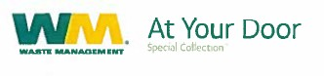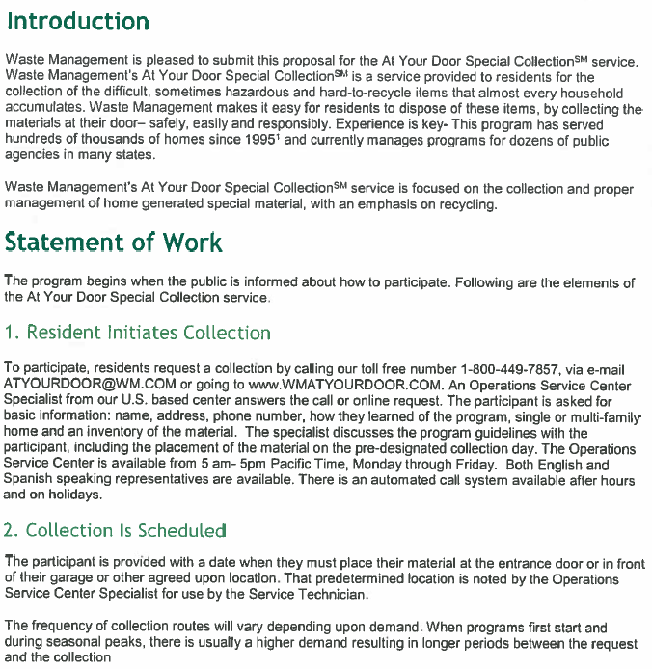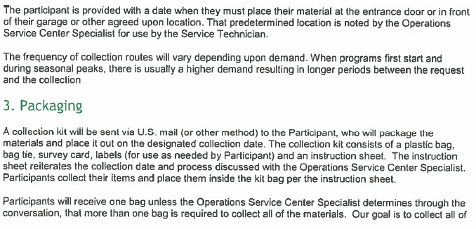

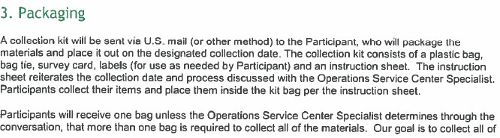

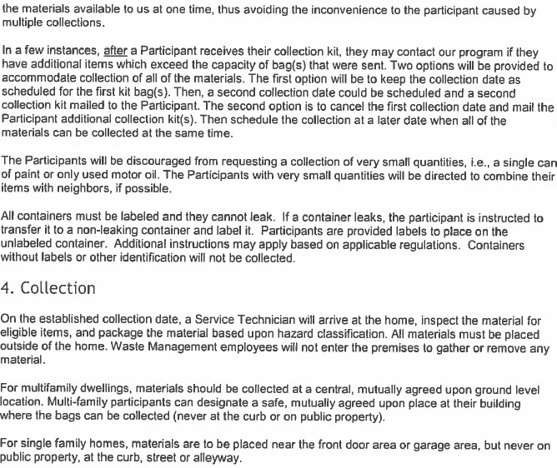

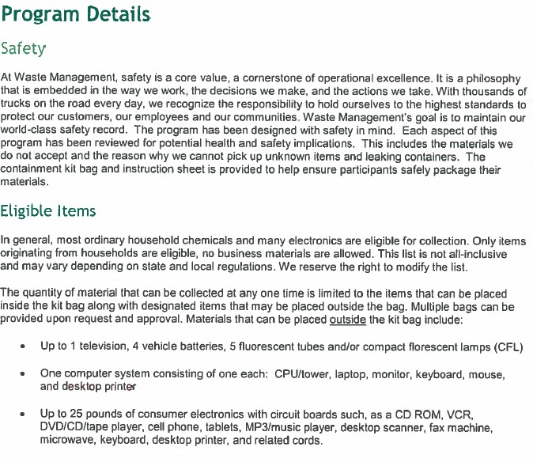

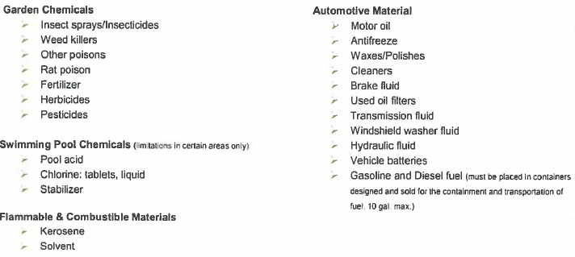

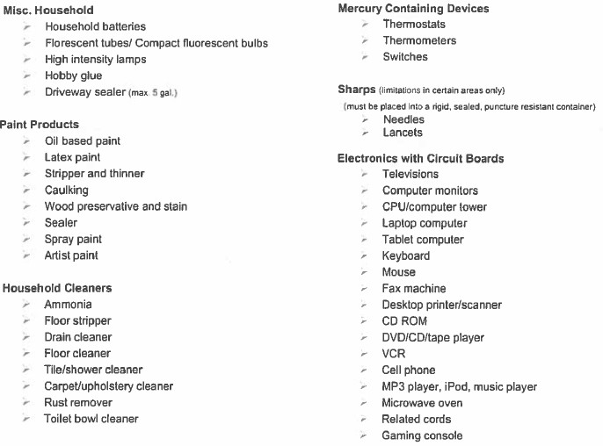

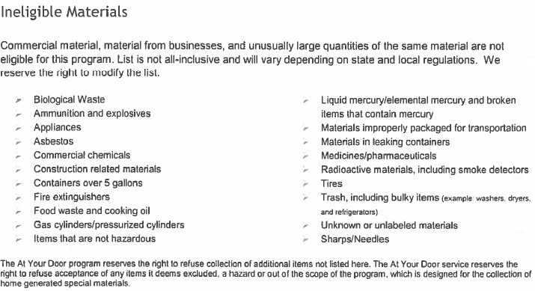

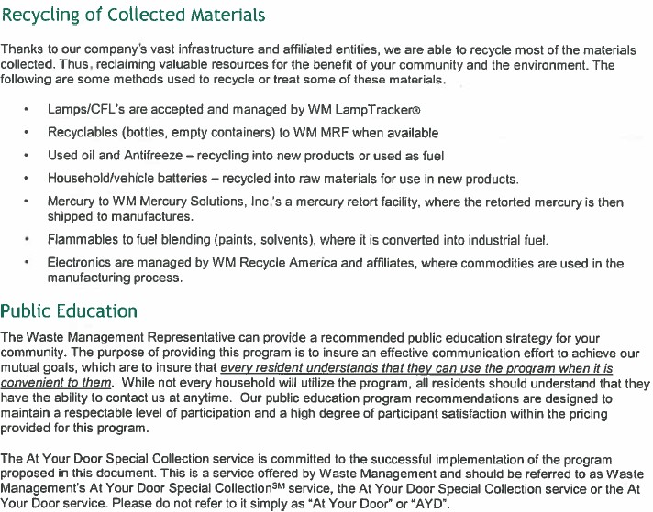

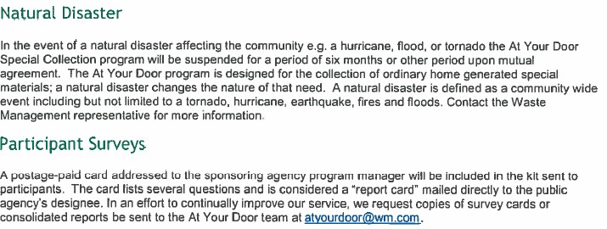

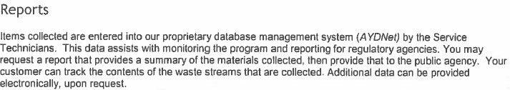

At Your Door Special Collection is a service of Waste Management. Collection services will be provided by a properly licensed/permitted subsidiary of Waste Management. ©WM Curbside, LLC. All rights reserved. At Your Door and At Your Door Special Collection are service marks of WM Intellectual Property Holdings, LLC. 2017-046

**EXHIBIT B**

**MUNICIPAL SOLID WASTE AGREEMENT**

**Chapter 2-3 - GARBAGE AND TRASH COLLECTION AND DISPOSAL of the City of Universal City Code of Ordinances is hereby amended as follows:**

Sec. 2-3-1. – Solid Waste Program Established.

The City’s solid waste collection, transportation and disposal program is hereby established for all residents and businesses of the City of Universal City, Texas.

Sec. 2-3-2. – Purpose.

The accumulation of garbage, recyclable material, rubbish, brush and other refuse constitutes a public nuisance, a health hazard, a fire hazard and a safety hazard. Therefore, it shall be required that owners and tenants of private residences, private commercial buildings and businesses, and the occupants of all private noncommercial buildings which accumulate refuse, deposit their garbage, rubbish, brush, and other refuse for removal by the agent designated by the city. Such owners, renters and occupants shall maintain the premises of the buildings and property free of accumulations of all other waste materials and nuisance materials. Such owners, renters and occupants shall not allow materials intended for recycling to create a nuisance on the premises of buildings and properties. All waste materials shall be disposed of in a place and by methods deemed appropriate by the City. The purpose of this chapter is to provide for a method of collecting and disposing of garbage, recyclable material, rubbish, brush, and other refuse, and to maintain neighborhood quality and aesthetics and maintenance of property values by providing for the general health and welfare.

Sec. 2-3-3. – Services of Franchisee Required.

It is hereby prohibited for any individual to utilize the services of any individual or corporation for purposes of residential solid waste collection other than the City’s designated solid waste franchisee. Every residential occupant shall subscribe to the services of the franchisee having the exclusive franchise for collection and disposal service with the City. It is declared to be unlawful for the occupant of any of the premises described in this section to fail or neglect to provide for the removal of solid waste as required under this Chapter.

Sec. 2-3-4. - Definitions.

For the purpose of this chapter, certain terms and words are hereby defined. Terms and words not specifically defined shall be construed with common usage and meaning or as defined by state or federal agencies having oversight jurisdiction:

**At Your Door (AYD) Program**: A special collection service provided by Contractor or its affiliate to residents for the collection of difficult, sometimes hazardous and hard-to-recycle items generated by a household.

**Bag:** A plastic sack no more than 33 gallons in size designed to store Waste with sufficient wall strength to maintain physical integrity when lifted by the top to which a Customer may affix a Pink Tag and place curbside for collection.

**Brush**: Tree, shrub, grass, brush trimmings, leaves, limbs, shrubbery and other yard waste and green material securely tied together to form an easily handled bundle or placed in that is generated by or at Residential Unit Customer locations and placed curbside for collection. Limbs shall not exceed four feet (4’) in length or six inches (6”) in diameter.

**Bulk Waste**: Furniture, bicycles (without tires), refrigerators that have CFCs removed by a certified technician, stoves, and other oversized wastes which are customary to ordinary housekeeping operations of a Residential Unit and whose large size precludes or complicates its handling by normal solid waste collection, processing or disposal methods.

**City**: The City of Universal City, Texas.

**Commercial Unit**: All commercial businesses and establishments, including, but not limited to, stores, offices, restaurants, warehouses, and related facilities, premises, locations or entities, public or private, within the corporate limits of the City.

**Commercial Waste**: All Garbage, Waste, and Rubbish generated by a Commercial Unit, excluding Unacceptable Waste.

**Construction Debris**: Waste building materials resulting from construction, remodeling, repair, or demolition operations that are directly or indirectly the by-products of construction work or that result from demolition of buildings or other structures, but specifically excluding land-clearing debris, yard debris, or used asphalt, asphalt mixed with dirt, sand, gravel, rock, concrete, or similar materials.

**Contract Administrator**: That person, or his designee, designated by the City to administer and monitor the provisions of this Chapter.

**Contractor**: The entity or agent designated and authorized as exclusive Franchisee by the City to administer this Chapter.

**Customer**: The owner or tenant of a Residential Unit, Industrial Unit, or Commercial Unit located within the City, and identified by the City as being eligible for and in need of the services provided by the Contractor under this Chapter.

**Dead Animals**: Animals or portions thereof that have expired from any cause except those slaughtered or killed for human use.

**Disposal Site**: A duly permitted sanitary landfill selected by Contractor.

**Dumpster**: Metal receptacle designed to be lifted and emptied mechanically for use only at Commercial Units or Industrial Units.

**Excess Garbage, Waste or Rubbish**: Anys garbage, waste, or rubbish placed outside of a polycart and not bearing a Pink Tag shall be deemed excess Garbage, Waste or Rubbish and will not be picked up. If a Residential Unit is found to have excessive trash on three (3) or more trash or recycling days in a six (6) month period, then the City has the authority to order an additional Polycart for that Residential Unit and add it corresponding Residential Unit customer account.

**Garbage**: Solid Waste consisting of putrescible or animal and vegetable waste materials resulting from the handling, preparation, cooking, and consumption of food, including waste materials from markets, storage facilities, handling and sale of produce and other food products, and all Dead Animals of less than ten pounds (10 lbs.) in weight, except those slaughtered for human consumption.

**Hazardous Waste**: Any material or waste identified or listed as a hazardous waste by the administrator of the Environmental Protection Agency under the Federal Solid Waste Disposal Act as amended by RCRA, 42 U.S.C. §6901, et. seq., as amended.

**Industrial Unit**: All industrial businesses and establishments, including manufacturing facilities, temporary construction sites, and other premises, locations or entities, public or private, within the corporate limits of the City.

**Industrial Waste**: Solid Waste resulting from or incidental to any process of industry, manufacturing, construction, demolition, mining or agricultural operations. Industrial Waste includes Construction Debris, but excludes Unacceptable Waste.

**Light Commercial Unit**: A retail or light commercial type of business, which generates no more than one (1) cubic yard of Garbage, Rubbish, and Refuse per week, excluding Unacceptable Waste.

**Medical Waste**. Waste generated by health care related facilities and associated with health care activities, not including Garbage or Rubbish generated from offices, kitchens, or other non-health-care activities. The term includes Special Waste from health care-related facilities which is comprised of animal waste, bulk blood and blood products, microbiological waste, pathological waste, and sharps as those terms are defined in 25 TAC §1.132 (relating to Definitions).

**Non-Recyclables:** Any materials in the Single Stream Materials that are not Recyclables.

**Pink Tag:** A tag or adhesive sticker developed, produced, and sold by the City to Residential Customers to affix on to a bag into which Waste has been deposited and then the bag has been placed curbside for Contractor to collect on that resident’s regular collection day. Pink tag use is restricted to Residential Waste or Brush in a Bag as herein defined. Pink tags shall not be used for Medical Waste, Special Waste, Bulky Waste, or Construction Debris as herein described. One (1) Pink Tag is required for each and every Bag. Bags without a Pink Tag will not be picked up and be deem as Excessive Garbage, Waste, or Rubbish.

**Polycart**: A Contractor owned rubber-wheeled receptacle with a maximum capacity of 90 - 96 gallons constructed of plastic, metal and/or fiberglass, designed for automated or semi-automated solid waste or recyclables collection systems, and having a tight-fitting lid capable of preventing entrance into the container by small animals.

**Recyclable Materials or Recyclables**: A material that has been recovered or diverted from the non-hazardous waste stream for purposes of reuse, recycling, or reclamation, a substantial portion of which is consistently used in the manufacture of products that may otherwise by produced using raw or virgin materials. Recyclable Material is not solid waste. However, Recyclable Material may become Solid Waste at such time, if any, as it is abandoned or disposed of rather than recycled, whereupon it will be solid waste, with respect to the party actually abandoning or disposing of such material.

**Residential Unit:** A residential dwelling, such as a home, townhouse or condominium unit, within the service area of the City occupied by a person or group of persons comprising not more than four families and serviced through the collection of Polycarts. A Residential Unit shall be deemed occupied when either water or domestic light and power services are being supplied thereto.

**Residential Waste**: All Garbage, Rubbish and Waste generated by a Customer at a Residential Unit, excluding Unacceptable Waste and Construction Debris generated by a Third-Party Provider.

**Rubbish**: Nonputrescible Solid Waste (excluding ashes), consisting of both combustible and noncombustible waste materials. Combustible rubbish includes paper, rags, cartons, wood, wood shavings, furniture, rubber, plastics, yard trimmings, leaves, brush or similar materials; noncombustible rubbish includes glass, crockery, tin cans, aluminum cans, metal furniture, and similar materials that will not burn at ordinary incinerator temperatures (1,600 degrees Fahrenheit to 1,800 degrees Fahrenheit).

**Single Stream Materials**: means all materials deposited by a Customer in the Customer’s Recycling Cart, including any Recyclables and Non- Recyclables.

**Solid Waste or Waste**: Non-hazardous solid waste generated by a Customer at a Residential Unit to be collected by Contractor under this Ordinance. Solid Waste excludes Unacceptable Waste.

**Special Waste**: Waste that requires special handling and management due to the nature of the waste, including, but not limited to, the following: (A) containerized waste (e.g. a drum, barrel, portable tank, box, pail, etc.), (B) waste transported in bulk tanker, (C) liquid waste, (D) sludge waste, (E) waste from an industrial process, (F) waste from a pollution control process, (G) residue and debris from the cleanup of a spill or release of chemical(s), or (H) any other waste defined by applicable law, rule or regulation as "Special Waste".

**Third-Party Provider**: A commercial business enterprise or third party that provides any type of services to Residential Units or construction sites.

**Unacceptable Waste**: Any waste or material that (i) the acceptance and handling of which by Contractor would cause a violation of any permit, condition, legal or regulatory requirement, (ii) substantial damage to Contractor's equipment or facilities, or (iii) contains information (in hard copy or electronic format) that is protected or regulated under any local, state or federal privacy or data security laws, including without limitation, the Health Insurance Portability and Accountability Act (HIPAA), or (iv) presents a danger to the health or safety of the public or Contractor's employees, and/or (v) is or contains Hazardous Waste, Special Waste, untreated Medical Waste, Dead Animals weighing ten pounds (10 lbs.) or greater, or (vi) is or contains solid or dissolved material in domestic sewage, or solid or dissolved material in irrigation return flows, or industrial discharges subject to regulation by permit, or (vii) is soil, dirt, rock, sand, and other natural or man-made inert solid materials used to fill land if the object of the fill is to make the land suitable for the construction of surface improvements, or (viii) results from activities associated with the exploration, development, or production of oil or gas or geothermal resources.

**Unusual Accumulations or Overage**: As to Residential Units, any Waste placed curbside for collection or placed outside, on top of or sticking out of a Polycart, other than Bags with a Pink Tag affixed to them. As to Commercial Units and Industrial Units, (i) any Waste or other material placed on top of or located outside the Dumpster, Roll- off Bin or Compactor regularly used for such collection service or (ii) in excess of the applicable weight limits or intended capacity such that the lid will not completely close.

Sec. 2-3-5. – Collection Services.

**A. Residential Collection**: A Residential Unit Customer may request an additional Polycart and Contractor must provide an additional Cart at the rate set forth in Schedule A. A Residential Unit Customer may purchase a Pink Tag from the City and affix the Pink Tag to a Bag of Waste. Contractor will collect properly placed Bags that have a Pink Tag affixed thereto on the Residential Unit Customer’s regular collection day.

1. Contractor shall collect Residential Waste generated at a Residential Unit and placed in that Residential Unit’s Waste Polycart two times per week, but not less than three days between collection times within the same week. The Contractor shall not be obligated to collect any Waste not properly contained in the Customer’s Waste Polycart.
2. Construction Debris generated at a Residential Unit by the owner or tenant of that Residential Unit, and not using the services of a Third-Party Provider, shall be subject to the Bulky Waste limitations set forth in this Ordinance. Any Waste or Bulky Waste generated by an owner or tenant, or a Third-Party Provider is Commercial Waste and Contractor has no obligation to collect those materials.

**B. Brush Collection**: Contractor shall provide quarterly or four times per year collection service

to Residential Units for collection of Brush. Contractor and City shall agree on the dates/times for such services and shall mutually be responsible for notifying residents of collection dates. Contractor agrees to collect up to, but not to exceed, a total of six (6) cubic yards of Brush from each Residential Unit.

Contractor shall have no obligation to collect any Brush in excess of the above volume, Brush

shall be placed within three (3) feet of the curb, swale, paved surface of the roadway, closest

accessible roadway, or other location agreed to by Contractor and Customer,

that will provide safe and efficient accessibility to Contractor's collection crew and vehicle

Collection of Curbside Residential Unit Bulky Waste is not included. Construction Debris generated by a Third-Party Provider hired by a Residential Unit Customer and generated and/or located at that Residential Unit is considered and shall be treated as Commercial Waste.

**C. Residential Door-to-Truck Service:** Contractor will provide, at no cost to the City or the Residential Customer, Residential Door-To-Truck waste collection for up to 20 Residential Customers that the City determines have demonstrated a need or hardship necessitating this special service. The City has sole responsibility for determining which Residential Unit Customers qualify for this special service. The City will provide Contractor with a complete list of qualifying Customers’ addresses each time a modification is made. Door-to-Truck collection service means the Customer places their Waste Polycart near their garage or carport rather than curbside. Contractor may refuse to provide this service if the location of the Polycart exceeds 150 feet from the curb line or edge of pavement and no such service will be provided for Bulky Waste or Brush collection.

**D. Residential Recyclables Collection:**

1. Contractor shall collect Residential Unit Recyclables once per week, per an agreed upon schedule with the City. Residential Unit Customers must place all Recyclables into the Recycling Cart. Contractor shall not be required to collect any Recyclable Materials that are not placed in a Recycling Cart. In addition, Contractor shall not be required to collect Recyclable Materials if the Customer does not segregate the Recyclable Materials from the remainder of the Residential Waste.
2. **Recyclables Specifications**: The following are Recyclables that Customers may deposit into the Recyclables Carts. To be acceptable, the Recyclables must be dry, loose (not bagged), unshredded, empty and include only the following:

|  |  |
| --- | --- |
| Aluminum cans | Newspaper |
| PET bottles with the symbol #1 – with screw tops only | Mail |
| HDPE plastic bottles with the symbol #2 (milk, water bottles detergent, and  shampoo bottles, etc.) | Uncoated paperboard (ex. cereal boxes; food and snack boxes) |
| PP plastic bottles and tubs with symbol # 5 - empty | Uncoated printing, writing and office paper |
| Steel and tin cans | Old corrugated containers/cardboard (uncoated) |
| Glass food and beverage containers – brown, clear, or green | Magazines, glossy inserts and pamphlets |

**Non-Recyclables include, but are not limited to, the following:**

|  |  |
| --- | --- |
| Plastic bags and bagged materials (even if containing Recyclables) | Microwavable trays |
| Porcelain and ceramics | Light bulbs, Mirrors |
| Window or auto glass | Coated cardboard |
| Soiled paper, including paper plates, cups and pizza boxes | Plastics not listed above including but not limited to those with symbols #3, #4, #6, #7 and unnumbered plastics, including utensils |
| Expanded polystyrene | Coat hangers |
| Glass and metal cookware/bakeware | Household appliances and electronics |
| Hoses, cords, wires | Yard waste, construction debris, and wood |
| Flexible plastic or film packaging and multi-laminated materials | Needles, syringes, IV bags or other medical supplies |
| Food waste and liquids, containers containing such items | Textiles, cloth, or any fabric (bedding, pillows, sheets, etc.) |
| Excluded Materials or containers which contained Excluded Materials | Napkins, paper towels, tissue, paper plates, paper cups, and plastic utensils |
| Any paper Recyclable materials or  pieces of paper Recyclables less than 4” in size in any dimension | Propane tanks, batteries |
| Cartons | Aseptic Containers |

1. **Delivery Specifications.** Residential Unit Customers shall deposit only the Recyclables listed above into their Recyclables Carts. If a load of material does not meet these specifications, the Recycling Facility may reject the load and the City may be charged for the resulting transportation, handling, and disposal costs for the Non- Recyclables. The Recycling Facility or Contractor has the right to dispose of all residue, contamination, and Non-Recyclables resulting from or remaining after the processing of the materials collected from the Recyclables Carts. The City acknowledges that Contractor may face unforeseen charges or increases based on the recycling market, the quality of the materials collected within the City, and/or uncontrollable circumstances, including without limitation, changes in law, and the City agrees to pay these charges so long as Contractor provides the City with written documentation explaining or justifying the increase prior to the City’s payment.
2. **Recycling Market Changes:** The market for Recyclables continues to evolve and is volatile. As such, Contractor cannot make any representations as to the marketability of the Recyclables, and when no reasonable commercial market exists for a commodity, Contractor and/or the Recycling Facility reserves the right to dispose of that material. Contractor also reserves the right to add or delete materials from the list of Recyclables based upon requests or demands from the Recycling Facility, changes in market conditions, uncontrollable circumstances, governmental restraint, or changes in laws, rules, regulations, or ordinances, and Contractor will provide written notice to the City of those changes. The Recycling Facility reserves the right to dispose of particular Recyclables when no reasonable commercial market exists for a commodity. The City and Contractor may agree to amend the terms of the recycling portion to reflect the current market or legal conditions.

**E. Carts/Polycarts/Placement**:

1. Contractor agrees to provide one (1) Waste Polycart and (1) Recycling Polycart to each Residential Unit for the deposit of Waste and Recyclables. The Carts shall be placed by the Customer of a Residential Unit in a location that is readily accessible to Contractor and its collection equipment, not to exceed three (3) feet from the curb or edge of the travelled portion of the street, road or alley, and not to be located in a manner that will block the driveway or mailbox or otherwise inhibit proper servicing. The City shall aid Contractor in resolving problems of Cart location by the Customer. Customers shall not overload Carts, and the Carts shall be loaded such that the lids shall close securely.
2. Contractor shall not be required to collect (i) any Residential Waste or Recyclables that are not placed in a Polycart, (ii) any Residential Waste or Recyclables from a Polycart that is overloaded or whose lid cannot fully close, or (iii) a Polycart that is not properly placed curbside. Contractor shall have no obligation to collect Unusual Accumulations/Overage and may charge for the collection of same so long as Contractor provides a digital image or photograph of the Overage to the Residential Unit Customer upon request.
3. The Carts furnished by the Contractor hereunder shall remain the property of Contractor, and the Customer will have no interest in the Carts. The Carts shall remain at the location of the Residential Unit where delivered by Contractor. If a Cart is damaged beyond repair, the Contractor must provide a replacement Cart to the Residential Unit location at no charge. Any Cart removed from, lost or missing from a Customer location may be deemed lost, and Contractor must provide a replacement Cart at a cost of $70.00 per Cart to the City. The City may pass through the Contractor’s replacement Cart charge to the Residential Unit Customer at the City’s option.

**F. Residential Household Special Waste Collection Program**: Contractor agrees to provide a

residential household hazardous waste collection service pursuant to the terms set forth in

**Schedule C**, the At-Your-Door Program.

**G. Commercial and Industrial Unit Collection**: Contractor shall have the exclusive right to

collect and transport Commercial Waste from the Commercial Units and Industrial Waste from

the Industrial Units, respectively, utilizing Dumpsters, Compactors or Roll Off Bins, at such frequency as shall be reasonably requested and agreed to between the Customer and Contractor. The Dumpster, Compactor or Roll Off Bin shall be located on a concrete pad to accommodate equipment and at a location reasonably acceptable to Contractor. Contractor may, at its sole option, require Commercial or Industrial Unit Customers to enter individual contracts with Contractor, subject to the terms of this Agreement. If additional Roll Off Bins, Compactors, Dumpsters or collection services are needed by Commercial or Industrial Unit Customers beyond what Contractor can provide, the City and Contractor, upon mutual written agreement, may allow Contractor to use a third party to assist Contractor in providing the needed waste equipment or services hereunder on a temporary basis.

**H. Unusual Accumulations Collection/Overage**: Contractor shall have no obligation to collect Unusual Accumulations/Overage and may charge for the collection of same so long as Contractor provides a digital image or photograph of the Overage to the Commercial or Industrial Unit Customer upon request.

**I. Unacceptable Waste**: Contractor shall not be obligated to collect any Unacceptable Waste. Title to Unacceptable Waste shall not pass to Contractor, and liability for any Unacceptable Waste shall remain with the generator of such material.

**J. Services Provided to City or City Facilities:**

1. The Contractor will provide, at no charge, Waste collection services two times per week, but not less than three days between collection times within the same week, at the City facilities listed in Schedule B. The Waste containers provided at each City facility will be of the size and type appropriate to the volume and characteristics of the Waste and as set forth in Schedule B. Additional or new City facilities or buildings will only be serviced by Contractor at no charge upon the mutual written agreement of both parties.
2. Contractor will provide to the City, at no additional charge, two (2) thirty cubic yard Roll-Off container at a location determined by the City Public Works Department and agreed to by Contractor. Contractor will provide a maximum of 180 prescheduled pulls each calendar year at no charge to the City. These 180 Roll-Off pulls must be used during each calendar year and may not be accumulated and rolled into the following calendar year. The weight of the Roll-Off shall not exceed eight (8) tons per pull. The City is required to electronically notify the Contractor of the requested pull(s) for the 30 cubic yard Roll-Off via the Contractor’s PSS Customer Service Team. Contractor shall charge and the City agrees to pay the rate set forth in Schedule A for any Roll-Off load heavier than the eight-ton limit, provided Contractor notifies the City within three (3) business days of an overweight load. Otherwise, there will be no additional charge for over-limit loads. Additional pulls will be charged to the City per the then-current rates in Schedule A.
3. Contractor will provide special collection services daily at designated locations during the City's annual fall and spring cleanup. Six (6) forty-cubic-yard roll-off containers will be provided to the City for each such annual fall and spring cleanup where only residential Bulky Waste will be collected. Container and pickup service will be at no cost to the City. Such fall and spring clean-ups shall not exceed two (2) weeks each and number of roll-off container pulls shall not exceed 72 for each clean-up. The City will be charged the current applicable rate in Schedule A for any load heavier than the eight-ton limit, provided Contractor notifies the City within three (3) business days of an overweight load. Otherwise, there will be no additional charge for over-limit loads. Additional pulls will be charged to the City at the then-current rate in Schedule A. Contractor shall have no obligation to haul any roll-off that contains construction, commercial, or industrial waste. The City will be requested to remove such waste from the roll-off. If the City is unable to remove the waste, Contractor has the right to transport and dispose of the roll-off contents at the applicable rate for such waste type.

Sec. 2-3-6. – Collection Operations.

**A. Hours of Operation**: Collection of Residential Waste and Light Commercial Waste shall begin no earlier than 7:00 A.M. and may not extend beyond 6:00 P.M. Collection of Commercial Waste or Industrial Waste shall begin no earlier than 6:00 A.M. and may not extend beyond 6:00 P.M. No collections shall be made on Sunday.

**B. Routes of Collection**: Collection routes shall be established by the Contractor as reasonably approved by City. City shall provide Contractor with maps of the City containing sufficient detail for Contractor to design collection routes. Contractor shall provide to the City route maps for approval by the City, which approval shall not be unreasonably withheld.

**C. Holidays**: The following are holidays for purposes of this Ordinance:

|  |  |  |
| --- | --- | --- |
| New Year's Day | Labor Day | Thanksgiving Day |
| Independence Day | Memorial Day | Christmas Day |

Contractor may decide to observe any or all of the above-mentioned holidays by suspension or collection service on the holiday, but the Contractor is responsible for providing make-up collection for residential routes that occur on specified holidays. Make-up days are the next business day following the holiday and every remaining route day scheduled for that week will be pushed a day.

**D. Complaints**: Customer complaints shall be directed by the City to Contractor, and Contractor shall promptly resolve any complaint based on the nature of the complaint. Contractor shall be responsible for maintaining a log of complaints based on the information provided to Contractor by the City, and shall provide the City, on a monthly basis, with copies of all complaints indicating the date and hour of the complaint, nature of the complaint, and the manner and timing of its resolution. Any alleged missed pickups will be investigated and, if such allegations are verified, Contractor shall arrange for collection on the next business day after receipt of such complaint. If the missed pickup is a result of Customer related acts or omissions, the City shall take appropriate action to cause such Customer to subsequently properly set out such Waste.

**E. Collection Equipment**: Contractor, at its sole cost and expense, agrees to furnish, all trucks, equipment, machines, and labor which are reasonably necessary to adequately, efficiently, and properly collect and transport Waste from Customers serviced by Contractor in accordance with this Ordinance.

**F. Disposal**: The Contractor shall deliver Waste collected to a duly permitted Disposal Site operated in compliance with rules stipulated by the applicable state agency and/or the U.S. Environmental Protection Agency.

**G. Spillage**: The Contractor shall not be responsible for scattered Refuse unless the same has been caused by Contractor, in which case all scattered Refuse shall be picked up immediately by Contractor.

**H. Vicious Animals**: Employees of the Contractor shall not be required to expose themselves to the dangers of vicious animals in order to accomplish Refuse collection service. Contractor shall immediately notify the City, in writing, of such condition and of his inability to make collection.

**I. Protection From Scattering**: Each Contractor vehicle shall be equipped with a cover which may be net with mesh not greater than one and one-half (1-1/2) inches, or tarpaulin, or fully enclosed metal top to prevent leakage, blowing or scattering of refuse onto public or private property.

**J. Point of Contact**. All dealings and contacts between Contractor and the City shall be directed between Public Sector Solutions Manager of Contractor, or such other individual identified by Contractor, and the Contract Administrator designated by the City.

Sec. 2-3-7. – Billing.

1. City shall provide billing and bill collection services for Residential Units. Within twenty-one (21) days of the end of each month during which collection services are provided by Contractor hereunder, Contractor shall submit to the City an invoice setting forth sums due by the City to Contractor for services rendered for the prior month. The City shall notify, in writing, and request that Contractor suspend services to any Residential Unit Customer that has failed to pay the City for Waste or Recyclables collection services, and Contractor may suspend service to such delinquent Customer until notified by the City to resume such services. The City’s franchise, billing, or administrative fees, if any, will not be included in the Contractor’s invoices to the City for services provided to Residential Units. The City shall include in its bills sent directly to Residential Units any City franchise, billing, or administrative fees and shall retain those fees.
2. Contractor shall provide billing and bill collection services for all Commercial and Industrial Unit Customers including Light Commercial Customers, that use Polycarts, Dumpsters, Compactors, or Roll-Off Bins. Within 21 days of the end of each month during which collection services are provided by Contractor hereunder, Contractor shall submit an invoice to each Commercial and Industrial Customer.
3. Contractor shall include in its invoices to the Customer the City’s franchise fee of ten percent (10%) (“Franchise Fee”) for Commercial and Light Commercial Customers that use Polycarts or Dumpsters, along the City’s franchise fee of 15 percent (15%) for Industrial Compactors or Roll-Offs. The Franchise Fee payments actually received by Contractor from Customers shall be paid by the Contractor to the City within thirty (30) days after the last day of the month of Contractor’s actual receipt of such monies. The rates set forth in **Schedule A** for Commercial, Light Commercial, and Industrial Unitsinclude the City’s Franchise Fee. The rates set forth in Schedule A for Residential Units DOES NOT include the City’s 10% franchise fee. The Franchise Fee shall not be added to and/or be assessed upon any state or local sales tax or other governmental fees, such as the state of Texas disposal fee, or the Franchise Fee itself.
4. Invoices sent to Commercial, Light Commercial and Industrial Unit Customers by Contractor shall be paid within thirty (30) days after receipt of such invoice by Customer or in accordance with each individual contract between Customer and Contractor, if any. All past due invoices shall bear interest at the highest rate permitted by law. Contractor may suspend service to any Customer that is delinquent in payment directly to Contractor. If Contractor suspends service to a Customer for failure to timely pay Contractor’s invoices, Contractor has the right to charge a service reactivation fee and/or finance charges or late payment fees if such service to the Customer is reinstated.

Sec. 2-3-8. – Modification to rates.

**A. CPI Adjustment**. Base Rates for services may be adjusted annually by eighty-five percent (85%) of the average monthly percentage increase that the Consumer Price Index, US City Average for All Urban Consumers, Garbage and Trash, Not Seasonally Adjusted, Base Period December 1983 = 100 (published by the United States Bureau of Labor Statistics, Consumer Price Index) (the “C.P.I.”) has increased over the 12 most recently published months. The C.P.I. published on the first Monday prior to the end of June (or the first business day thereafter if such Monday is a Federal Holiday) shall be used to determine the monthly percentage increase change. The average will be determined by calculating the percentage increase change in the CPI each month during the applicable 12-month period. Once that average is determined, then the average increase change for the 12- month period for the prior year will be subtracted and that sum will be multiplied by 85%. The product shall be the CPI adjustment component of the annual modification to Base Rates. In the event the U.S. Department of Labor, Bureau of Labor Statistics ceases to publish the C.P.I., the parties hereto agree to substitute another equally authoritative measure of change in the purchasing power of the U.S. dollar as may be then available so as to carry out the intent of this provision. The percentage increase change shall be multiplied by 85% and the product thereof shall be the “CPI Adjustment Component” of the annual modification to Base Rates.

**B. Fuel Adjustment**. Base Rates may be adjusted by 15% of the average percentage increase or decrease in the price of compressed natural gas determined by the Energy Information Administration of the US Department of Energy (“EIA/DOE”)’s Natural Gas Commercial Price-Texas Index during the applicable 12-month time period. The average will be computed by calculating the percentage change in the EIA/DOE price each month during the applicable 12-month period. Once that average is determined, then the average change for the 12-month period during the prior year will be subtracted and that sum will be multiplied by 15%. product thereof shall be the fuel adjustment component” of the annual modification to Base Rates.

**C. Additional Adjustments**. Contractor may also be entitled to an increase in Base Rates from time to time during the term of this Agreement to offset any substantiated change in conditions which increase the Contractor’s costs, including but not limited to, increases in disposal costs, increases in landfill fees, changes in the ordinances under which the Contractor is to operate, or changes in federal, state or local laws, rules or regulations. Documentation of such increases shall be submitted to the City upon the City’s request.

Sec. 2-3-9. – Franchisee Insurance Requirements.

Contractor shall procure and maintain insurance against claims for injuries to persons or damages to property, which may arise from or in conjunction with the performance of the work hereunder by the Contractor, its agents, representatives, employees, or subcontractors. The City shall be named as an additional insured under the policies, except for workers’ compensation, and shall have coverage for liability assumed under an insured contract. Contractor shall provide the City with a certificate of insurance reflecting the City’s additional insured status and agreeing to give the City at least 30 days’ written notice in case of policy termination. The cost of such insurance shall be borne by the Contractor.

Minimum Limits of Insurance**:**

|  |  |  |
| --- | --- | --- |
| **Type of Coverage** | **Per Occurrence Minimum** | **Aggregate Minimum** |
| Workers Compensation Employer’s Liability | Statutory  $500,000 | As required by law |
| Commercial General Liability | $1,000,000 | $1,000,000 |
| Auto Liability  Bodily Injury Property Damage | $1,000,000  $1,000,000  $ 500,000 | $1,000,000 |
| Umbrella Liability Policy | $2,000,000 | $2,000,000 |

Sec. 2-3-10. – License and Taxes.

Contractor shall obtain at its sole expense all licenses and permits required by the City and the State and shall maintain same in full force and effect.

Sec. 2-3-11 – Performance Bond.

The Contractor shall furnish a performance bond as security for the faithful performance of this Ordinance. Said performance bond will be in the amount of $20,000 and will be renewed on an annual basis. The Contractor shall pay premiums for the bond. A certificate from the surety showing that the bond premiums are paid in full shall accompany the bond. Such certificate shall be submitted to the City with the bond on an annual basis. The surety on the bond shall be a duly authorized corporate surety authorized to do business in the State of Texas.

Sec. 2-3-12. – Applicability of state law.

The provisions of this Chapter are adopted under Texas Health and Safety Code Chapters 361, 363, and 364.

1. The regulations promulgated in this chapter cover all aspects of municipal solid waste management under the authority of the State and are based primarily on the stated purpose of Vernon Texas Statue and Codes, Health and Safety Code ch. 361, as amended, hereafter referred to as the Texas Solid Waste Disposal Act. The owner or operator of a municipal solid waste landfill (MSWLF) facility shall comply with any other applicable federal rules, laws, regulations or other requirements.
2. All permits, including any special provisions therein, issued by the applicable State Department shall remain in force after the effective date of the ordinance from which this article is derived. To the extent that a standard has been changed by this article, the permittee may continue to operate under standards contained in previously issued permits, except for those requirements mandated by EPA 40 C.F.R. §§ 257 and 258, as amended, which implement certain requirements of subtitle D of the Resource Conservation and Recovery Act (RCRA). For those Federally mandated requirements, the permittee is under an obligation to apply for a change to his permit in accordance with Federal and State law, as applicable, to incorporate the required standard. Timely submission of a request for a permit change qualifies the owners or operators of existing MSWLF units for interim status. MSWLF facility owners or operators with interim status are treated as having been issued a permit modification or amendment until the Executive Director makes a final determination on the permit modification request or the commission makes a final determination on the permit amendment request. Facility owners or operators with interim status must comply with the requirements of this article upon the effective date of this article.

Sec. 2-3-13. – Enforcement.

The provisions of this Chapter shall be enforced by the Director of Public Works or his duly appointed representative, and it shall be unlawful for any person to interfere with or hinder the Director of Public Works or his duly appointed representative in the exercise of his duties under this chapter. Notwithstanding any provisions contained herein to the contrary, the Director of Public Works or his duly appointed representative are hereby granted the authority to issue citations to persons violating any provision of this article.

Sec. 2-3-14. – Offense.

(a)    Any person violating or failing to comply with any provision or requirement of this article, who continues to violate or fails to comply with same, shall also be deemed guilty of a misdemeanor and, upon conviction thereof, shall be fined in an amount not to exceed $2,000.00, such offenses listed herein being violations of the health and safety ordinance of the City. A separate offense shall be deemed committed upon each day during or on which a violation or failure to comply occurs or continues to occur. This section shall be in addition to and cumulative of the provisions for abatement by the City of any nuisance created by the violation of this ordinance and the charging of the cost of abatement of said nuisance against the owner of the property.

(b)    Notwithstanding the foregoing, any violation of any provision of this chapter which constitutes an immediate danger or threat to the health, safety and welfare of the public may be enjoined in a suit brought by the City for such purpose.

(c)    In addition to any other remedies or penalties contained herein, the City may enforce the provisions of this article pursuant to the applicable provisions of Vernon Texas Statues and Codes, Local Government Code Ch.54, which chapter provides for the enforcement of municipal ordinances.

(d)    Allegation and evidence of a culpable mental state is not required for the proof of an offense defined by this chapter.

**Acknowledgement as “Exhibit B”**

UNIVERSAL CITY

______________________________

John Williams, Mayor

Attest: Approved as to form:

_________________________ _______________________________

Kristin Mueller, City Clerk Matthew J. Longoria, City Attorney

**Waste Management of Texas, Inc**

__________________________________

By JAMES C. FISH JR.

President and Chief Executive Officer

Sec. 2-3-15. – Schedules. SCHEDULE A

**(Base Rates)**

|  |  |  |
| --- | --- | --- |
| **RESIDENTIAL UNITS** | **FREQUENCY OF COLLECTION** | **Base RATE** |
| 1- WM Provided 96 Gallon Waste Cart - Curbside | 2x week | $ 22.11 |
| 1- WM Provided 96 Gallon Recycle Cart - Curbside | 1x week | Included |
| Household Hazardous Waste Collection - At Your Door | Unlimited | Included |
| Brush Waste (6 CY Allowance) - Curbside | 4x year | Included |
| Bulk Waste (Fall & Spring Cleanup) - Convenience Station | 2x year | Included |
| Each Additional WM 96 Gal Cart (Trash or Recycle) | -- | $ 8.55 |
| Pink Tag/Sticker | -- | $ 1.80 |

*Residential Unit rates and charges **DO NOT** include any current or future City mandated franchise, administrative, or billing fee.

|  |  |  |  |  |  |  |  |
| --- | --- | --- | --- | --- | --- | --- | --- |
| LIGHT COMMERCIAL UNIT TRASH COLLECTION RATES PER CONTAINER PER MONTH | | | | | | | |
|  | | | | | | | |
| **Container Size / Type** | **1XWK** | **2XWK** | **3XWK** | **4XWK** | **5XWK** | **6XWK** | **EXTRA PU** |
| Poly Cart PU (1 Cart) | $ 24.98 | $ 49.84 | -- | -- | -- | -- | -- |
| Poly Cart PU (2 Carts) | $ 49.84 | $ 99.89 | -- | -- | -- | -- | -- |
| Poly Cart PU (3 Carts) | $ 74.92 | $ 149.84 | -- | -- | -- | -- | -- |
| Poly Cart PU (4 Carts) | $ 99.89 | $ 199.77 | -- | -- | -- | -- | -- |

|  |  |  |  |  |  |  |  |
| --- | --- | --- | --- | --- | --- | --- | --- |
| COMMERCIAL UNIT TRASH COLLECTION RATES PER CONTAINER PER MONTH | | | | | | | |
|  | | | | | | | |
| **Container Size / Type** | **1XWK** | **2XWK** | **3XWK** | **4XWK** | **5XWK** | **6XWK** | **EXTRA PU** |
| 2 Yard FEL Container | $ 49.36 | $ 98.72 | $148.09 | $197.98 | $246.24 | $246.31 | $ 49.36 |
| 3 Yard FEL Container | $ 74.03 | $ 125.87 | $22.13 | $296.16 | $370.21 | $310.99 | $ 74.03 |
| 4 Yard FEL Container | $ 83.91 | $ 197.44 | $296.16 | $394.90 | $493.90 | $592.60 | $ 83.91 |
| 6 Yard FEL Container | $ 113.28 | $ 251.74 | $444.25 | $592.32 | $740.41 | $887.86 | $ 113.28 |
| 8-Yard FEL Container | $ 167.83 | $ 335.65 | $503.47 | $641.82 | $839.12 | $984.24 | $ 167.83 |
| 10 Yard FEL Container | $ 246.66 | $ 493.57 | $740.41 | $987.15 | $1,233.94 | $1,492.28 | $ 246.66 |

|  |  |  |  |  |  |  |  |
| --- | --- | --- | --- | --- | --- | --- | --- |
| COMMERCIAL UNIT RECYCLING COLLECTION RATES PER CONTAINER PER MONTH | | | | | | | |
|  | | | | | | | |
| **Container Size / Type** | **1XWK** | **2XWK** | **3XWK** | **4XWK** | **5XWK** | **6XWK** | **EXTRA PU** |
| 2 Yard FEL Container | $ 95.16 | $ 190.32 | -- | -- | -- | -- | $ 95.16 |
| 3 Yard FEL Container | $ 108.34 | $ 216.67 | -- | -- | -- | -- | $ 108.34 |
| 4 Yard FEL Container | $ 144.62 | $ 289.24 | -- | -- | -- | -- | $ 144.62 |
| 6 Yard FEL Container | $ 216.93 | $ 433.86 | -- | -- | -- | -- | $ 216.93 |
| 8-Yard FEL Container | $ 289.24 | $ 578.49 | -- | -- | -- | -- | $ 289.24 |
| 10 Yard FEL Container | $ 362.14 | $ 724.28 | -- | -- | -- | -- | $ 362.14 |

|  |  |
| --- | --- |
| INDUSTRIAL UNIT ROLL-OFF COLLECTION RATES | |
|  | |
| **Container Size / Type** | **Collection Rate** |
| 20 Yard (Open-Top) | $ 503.17 |
| 30 Yard (Open-Top) | $ 545.73 |
| 40 Yard (Open-Top) | $ 572.15 |
|  | |
| Roll-Off Delivery (One Time) | $ 100.00 |
| Roll-Off Rental Fee (Per Month) | $ 150.00 |
| Roll-Off Rental Fee (Per Day) | $ 5.00 |
| *Each Additional 40 Yard (Open-Top) Pull for Fall/Spring Cleanup | $ 503.17 |
|  | |
| **Container Size / Type** | **Collection Rate** |
| 20 Yard (Compactor) | $ 484.07 |
| 30 Yard (Compactor) | $ 484.07 |
| 32 Yard (Compactor) | $ 484.07 |
| 34 Yard (Compactor) | $ 484.07 |
| 35 Yard (Compactor) | $ 484.07 |
| 40 Yard (Compactor) | $ 597.58 |
| 42 Yard (Compactor) | $ 597.58 |
|  | |
| Compactor Rental Fee (Per Month) | NEGOTIATED |
| Disposal Type I Landfill (Per Ton) | $ 39.00 |

*All Rates and charges (except Residential Unit rates) **INCLUDE** any current or future City mandated franchise, administrative, or billing fee.

**Acknowledgement as “Schedule A”**

UNIVERSAL CITY

______________________________

John Williams, Mayor

Attest: Approved as to form:

_________________________ _______________________________

Kristin Mueller, City Clerk Matthew J. Longoria, City Attorney

**Waste Management of Texas, Inc**

__________________________________

By JAMES C. FISH JR.

President and Chief Executive Officer

# SCHEDULE B

**City Facilities Services and Equipment**

|  |  |  |  |  |
| --- | --- | --- | --- | --- |
| **Facility Name** | **Address** | **Container Size** | **Container Type** | **Service Frequency** |
| Red Horse Park | 1100 North Blvd. | 3 YD | SEL Trash | 2x week |
| Public Works Yard | 265 Kitty Hawk | 8 YD | FEL Recycle | 1x week |
| Public Works Yard | 266 Kitty Hawk | 4 YD | FEL Trash | 1x week |
| City Hall | 2150 Universal City Blvd. | 8 YD | FEL Trash | 2x week |
| Olympia Hills Golf Course | 12900 Mt. Olympus | 8 YD (2 total) | FEL Trash | 2x week |
| Olympia Hills Golf Course | 12901 Mt. Olympus | 8 YD | FEL Recycle | 1x week |
| Cimarron Park | 368 Wagon Crossing | 96 Gal (4 total) | Polycart(s) | 2x week |
| Universal City Library | 100 Northview | 3 YD | FEL Trash | 2x week |
| Northview Park | 100 Randolph Plaza Dr. | 96 Gal (4 total) | Polycart(s) | 2x week |
| Animal Shelter | 134 Athenian Dr. | 6 YD | FEL | 2x week |

**Acknowledgement as “Schedule B”**

UNIVERSAL CITY

______________________________

John Williams, Mayor

Attest: Approved as to form:

_________________________ _______________________________

Kristin Mueller, City Clerk Matthew J. Longoria, City Attorney

**Waste Management of Texas, Inc**

__________________________________

By JAMES C. FISH JR.

President and Chief Executive Officer

# SCHEDULE C



**Acknowledgement as “Schedule C”**

UNIVERSAL CITY

______________________________

John Williams, Mayor

Attest: Approved as to form:

_________________________ _______________________________

Kristin Mueller, City Clerk Matthew J. Longoria, City Attorney

**Waste Management of Texas, Inc**

__________________________________

By JAMES C. FISH JR.

President and Chief Executive Officer